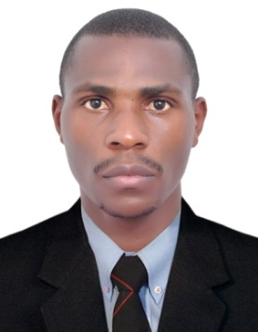
CURRICULUM VITAE

NGABIRANO

Email :ngabirano.383290@2freemail.com
Address : DUBAI UAE

APPLYING FOR SECURITY GUARD

PERSONAL PROFILE
A highly experienced Security Guard who is committed to complying with the highest work place standards in terms of attendance, health and safety, and conduct towards the public. I have a comprehensive working knowledge of Security Guard orders and duties, and am physically fit enough to be able to walk around for long periods.
PERSONAL DETAILS
Nationality : Ugandan
Marital Status : Single
Gender : Male
Languages Known : English
Visa Status : Visit visa

SUMMARY OF PERSONAL SKILLS
- Excellent ability to detect problems and report information to appropriate personnel.
- Remarkable ability to understand and follow safety procedures.
- Strong ability to understand and follow specific instructions and procedures.
- Profound ability to resolve customer complaints and concerns.
- Immense skills in providing protection services to individuals on campus.
- In-depth ability to gather data, compiles information, and prepares reports.
- Profound ability to communicate effectively, both orally and in writing
WORK EXPERIENCE
COMPANY NAME : SARCEEN SECURITY COMPANY (2014-2018)
DESIGNATION : SECURITY GUARD
DURATION : 4 YEARS
LOCATION : UGANDA
DUTIES AND RESPONSIBILITIES.
- Patrolled assigned areas on foot or in a vehicle to ensure personal, building, and equipment security.
- Examine doors, windows, and gates to determine that they are secure.
- Inform and warn violators of rule infractions, such as loitering, smoking, or carrying forbidden articles.
- Provide escort services for visitors, students, staff, faculty, and individuals responsible for transportation of monies to or from Storehouse’s depositories as required.
- Provide public assistance, including lockout services and information.
- Watch for and report irregularities, such as fire hazards, leaking water pipes, and security doors left unlocked; sounded alarm during fire outbreak and the presence of unauthorized persons.
- Perform periodic checks of emergency call boxes and street lights to ensure proper functioning; reported malfunctions as required.
- Prepare routine, standardized reports.
- Perform miscellaneous job-related duties as assigned.
EDUCATION AND PROFESSIONAL TRAINING
High School Education
DECLARATION

I certify that the above information are true and correct to the best of my knowledge and ability. If given a chance to serve you. I assure you that I will execute my duties for the total satisfaction of my superiors

