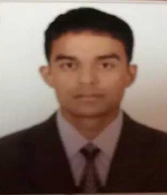CURRICULUM – VITAE

E-mail:[ devraj.383309@2freemail.com ]

Personal Profile

Name : Devraj
Date of Birth : 07/09/1989
Gender : Male
Nationality : Nepali
Marital Status : Married
Height : 5.6”cm
Weight : 55Kg
Age : 29 Years
Language known : Nepali, English Hindi &Arabic
Education : +2

Work Experience

- Worked as Internet operator in Qatar séance,2007-09-02 to 2011-10-05.

- Worked as data Entry job merojob.com. in Nepal, 2012-05-01 to 2014-07-22.
- Worked as accountant power security Services, PVT.LTD 2016-03 to 2017-06-15

Skills

- Xcell , MS office, Data Entry Tally, Internet,Networking , configuration , fast typing, hardware etc.

Declaration
I Hereby declare That all above mentioned particular are true &correct to the best of my knowledge & belief.

