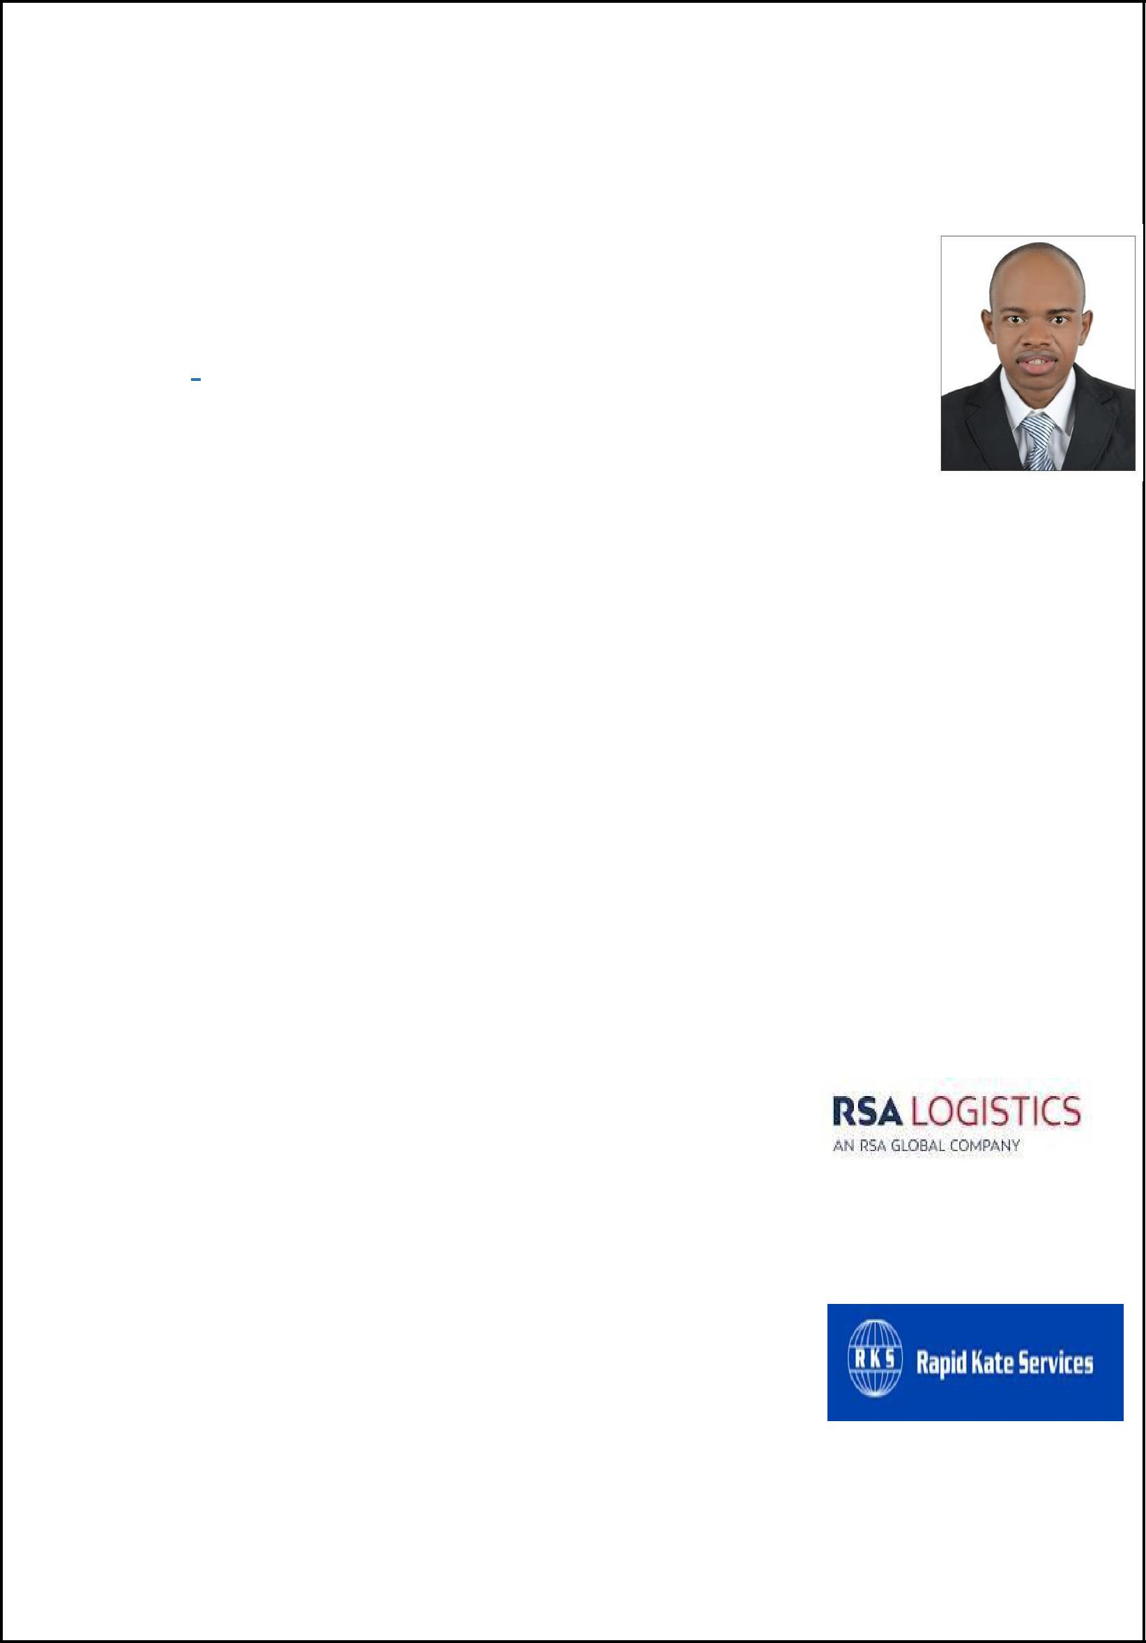

DAN

EMAIL: dan.383310@2freemail.com DUBAI, UAE

PROFESSIONAL SUMMARY

Highly organized and independent; able to effectively coordinate tasks to accomplish projects with timeliness and creativity.

HIGHLIGHTS

- Familiarity with computers, word processing and spreadsheets.

- Experience in fast paced and high-profile work.

- Strong verbal and written communication.

- Attention to detail and highly development sense of organizations.

- Self-motivated professional with Customer service Skills.

- Eager to meet challenges and assimilate new concepts.

- Personable individual whose strengths include cultural sensitivity.

WORK EXPERIENCE

Company: RSA LOGISTICS DWC-LLC

Tally Clerk

Tenure: May 2017 to till date.

Company: RAPID KATE SERVICES LTD-KENYA

Accounts Clerk

Tenure: July 2014 to April 2016

ACHIEVEMENTS/TASKS

RSA LOGISTICS DWC-LLC

- Managed warehouse operations with RF Gun Scanner, including shipping and receiving as well as inventory control

- Assist the supervisor in the coordination of shipping and receiving goods and scheduling workloads

- Implemented and reinforced RSA-logistics policies and warehouse safety guidelines.

- Organized and performed routine inventory checks.

- Maintain the quality in the warehouse and keeping track of all damage inventory then report to the supervising manager

- Preparing daily report for the warehouse activities and sharing with OPS manager on a daily basis

- Maintain records of inbound and outbound transaction.

RAPID KATE SERVICES LTD- KENYA

- Maintained integrity of general ledger, including the chart of accounts.

- Prepared accurate financial statements at end of the quarter.

- Reconstructed accounting records from clients’ checks and Cash receipt.

- Reviewed collection reports to determine the status of collections and the amounts of outstanding balances.

- Filed tax returns and prepared governmental reports in compliance with strict standards.

ACADEMIC QUALIFICATIONS

CERTIFIED PUBLIC ACCOUNTANT |  |  | AUGUST 2016 – APRIL 2017
KASNEB
Professional Accounting Course. Completed CPA PART I & II (SECTION 3)
BACHELOR OF BUSINESS ADMINISTRATION |  |  | SEPTEMBER 2010- JULY 2014
KENYA METHODIST UNIVERSITY
Major in Accounting and Minor in Finance
 | CERTIFICATIONS
HABC LEVEL 2 INTERNATIONAL AWARD (08/2017 – Present-DUBAI)
Emergency First Aid at work award.

- Providing appropriate first aid for minor injuries (including small cuts, grazes and bruises)

PERSONAL PROFILE

Nationality | : KENYAN
Date of Birth | :20/12/1991
Languages | : English, Kiswahili
Marital status | : Single
Visa Status | : Employment
 |  | DECLARATION

I hereby declare that the details furnished above are true to the best of my knowledge.

