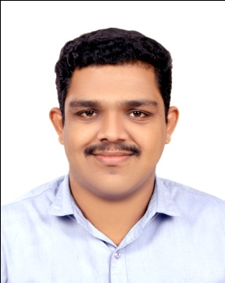
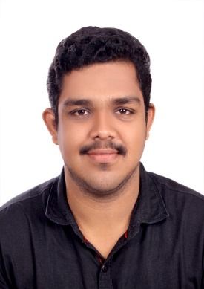
MIDHUN
Visa Status: On Visit Visa

Email : midhun.383366@2freemail.com
Nationality : Indian
Date of birth : 05 Sep 1995
Languages : Fluent in English, Hindi and Malayalam.

PROFESSIONAL PROFILE
Highly focussed, creative, self-motivated, team oriented with versatile skill set and commanding communication skills gained from industrial and educational experience, to obtain and secure a challenging position in an esteemed organization, which will use in-depth acquired knowledge and collective experience in a dynamic team-oriented environment.
EDUCATION & PROFESSIONAL DEVELOPMENT
2017
- Electrical Quality Control / Quality Assurance Engineer

2013 – 2017
- B-TECH in Electrical & Electronics
Saintgits College Of Engineering, M G University
2011 – 2013
- Board of Higher Secondary Exam
MD Seminary HSS, Kottayam, Kerala
2010 – 2011
- Secondary School Leaving Certificate, Grade 10
Girideepam Bethany HSS, Kottayam , Kerala
CAREER SUMMARY
TESTING ENGINEER– UNIPOWER TRANSFORMERS PVT LTD

One year experience (JUNE 2017 to August 2018) in Testing and Quality Control of distribution transformers.

RESPONSIBILITIES

- Carry out all routine and type tests according to IS.
- Conduct joint inspections with KERALA STATE ELECTRICITY BOARD LTD.
- Analysing the test results and issue reports.
- Ensure the quality by conducting the inspection in each stage during production and on completion.
- Make all repairing, Overhauling and servicing on all type of distribution transformers.
- Record preparation of daily production.
- Planning day to day production to achieve maximum production.

Type of tests:

- MeggerTest( Insulation Resistance Test), Turns Ratio Test, Resistance Test, Magnetic Balance Test, Magnetizing Current Test, Vector Group Test, Magnetizing Current Test, Short Circuit Test, Open Circuit Test, Brake Down Voltage Test of Oil( BDV), DVDF Test, High Voltage Test, Heat Run Test

INDUSTRIAL TRAINING
- KAKKAD POWER STATION (5 Days)
- TRAVANCORE CEMENTS LTD (10 Days)
PROJECTS & SEMINAR
- Main Project: Portable interactive white board
This project was aimed at providing quality education for the poor, converting ordinary projector into interactive white board at low cost.
Interactive whiteboards, more commonly known as SMART boards, have existed for quite a long time;however, very exclusively. By using simple infrared tracking using image processing we can make a new low cost interactive white board. This will make class rooms, boardrooms more interactive.
- Mini Project: Blind curve warning system
This project aims at warning drivers in blind curves by sensing the arrival of other vehicles. The system works by the help of laser transmitters and receivers with indication units.
- Seminar on True power curves of wind turbine:
The seminar focuses on energy management, predetermining the max and min wind energy that can be produced over an area.

ACHIEVEMENTS & ACTIVITIES
COLLEGE LEVEL
- Vice chairman of IEEE saintgits SB
- Organized the “do u know ardui no” programme
- Organized WIEE Congress

- Committee head of national level technical project competition –SRISHTI 2017
- Committee head of national level techno-cultur fest –NAKSHATRA 2016
- Committee head of national level technical fest- DYUTHI 2016
- Volunteer of NSS TECH CELL unit no:195
- Won second prize in Robowar held at GISAT college of engineering
SCHOOL LEVEL
- School band team member and won prizes in state youth festival
- NSS volunteer
TECHNICAL SKILLS
- Can handle various POWER ELECTRONIC equipments used for testing
- Electrical CAD
- MATLAB
- Well versed in computer skills like Ms. Word, Ms. Excel, Ms. Power point and Internet Usage.
PERSONAL SKILLS:
◘Leadership skills ◘ Open to all cultures◘ Making decisions and solving problems◘ Resolving conflicts and negotiating with others◘ Strong written and oral communication skills and ability to tailor information delivery to people of different backgrounds and experiences◘ Good time-management and organizational◘Proactive and quick learner
HOBBIES
Helps out in family owned business, Internet, reading, team games, sports

DECLARATION
I do hereby declare that the above given statements are true and correct to the best of my knowledge.

