CURRICULUM VITAE

MR. Faushan
Dubai, UAE

Email : faushan.383377@2freemail.com

Visa : Visit Visa

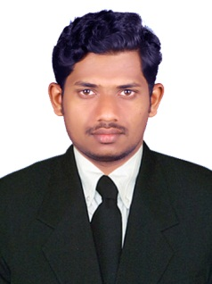

CAREER OBJECTIVE:
Seeking a suitable any position where can be utilized the experience for the company and personal growth as well.

MAJOR STRENGTH
- Excellent computer knowledge and communicationskills
- Hardworking and resultoriented
- Self-Motivated and HardWorker
- Problem solving skill
- Ability to learn new skillsquickly.

WORK EXPERIENCE:

Worked as an Production Maintenance Engineer in Queenex Tissue Paper Factory, Wadi Al Dawasir, Saudi Arabia, from June 2016– June 2018 (2Years)
Duties & Responsibilities:
  - Diagnosing faults
  - Repairing Machines
  - Fitting new parts and making sure Machines are working properly
  - Controlling maintenance tools, stores and equipment
  - Oiling and cleaning machinery and parts
  - Overhauling and replacing parts according to schedule
  - Responding immediately to machinery break down

Worked as Automobile Service Engineer in IIB Educational Private Limited, Kerala, India, from 2015 June to 2016June(1Year)
Duties & Responsibilities:
  - Guide Students to service auto mobile components
  - Maintain automobile engine and other parts
  - Teach the students about the automobile parts and their working mechanisms
  - Check the components regularly and inform the management if any modifications is necessary
  - Assemble and Dismantle each and every automobile parts to understand the students about them
  - Explain the students about the working of each and every component theoretically and practically
  - Provide lubrication of parts periodically

EDUCATIONAL QUALIFICATION:
Academic:
- Bachelor of Degree of Mechanical Engineering.
- Passed The Poly Technic Diploma in Mechanical Engineering.
- Passed The Secondary SchoolExamination.

Professional Qualification:
- Completed AutoCAD From Cadd Centre at2012
- Completed course on Solid Works From Cadd Centre at2012
- Completed CNC Lathe and Milling Programming From Jayam CNC CAD/CAM at2012

Personal Details:
Age & Date of Birth | : | 24 Yrs, 02-01-1994.
Sex | : | Male
Religion | : | Islam.
Marital Status | : | Unmarried
Nationality | : | Indian

Languages known
English -Fluent.
Hindi -Fluent.
Malayalam -Fluent.
Arabic - Fluent.

