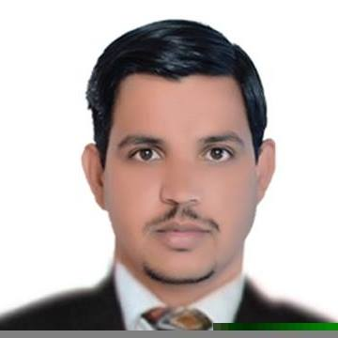
JAMIL
Email: jamil.383392@2freemail.com
PERSONAL DETAIL
- Date of Birth 05/04/1993
- Nationality Pakistani
- Religion Islam
- Marital Status Single
EDUCATIONAL RECORD

Qualification | Subjects | Institution | Year
Bachelors | Management Costing  Auditing | Rawalpindi Commerce of College Rawalpindi  (University of Punjab) | 2016
Intermediate | Maintain Entrepreneur Accounts | Govt. Community Model College Islamia 4  (Rawalpindi Board) | 2012
Matriculation | Arts | Private School  (Gujranwal Boar) | 2009

LANGUAGES
Proficient in following languages
• Urdu (Primary Language)
• English
Can read, write speak and understand

PROFESSIONAL SKILLS
• Have knowledge of computer basic IT and Ms Office and other application, internet browsing
• Ability ot generate entrepreneur innovative, modernization ideas
• Professional, kind and attractive attitude with colleague, clients.
• Have ability to work hard and organization improvement with keen desire for incresement of its revenue.

WORK EXPERIENCE
Present working in “Western Union” Ravi Exchange (Pvt) Ltd
• Working as a “Cashier”
• From March 2017 to July 2018
Detail of Job
• Prepare and manage office accounts on daily basis on their respective heads.
• Managing and preparing office files properly.
• Dealing for foreign currency
- Dealing with remittance in words and outwards

REFERENCES

• Will be furnished on demand

