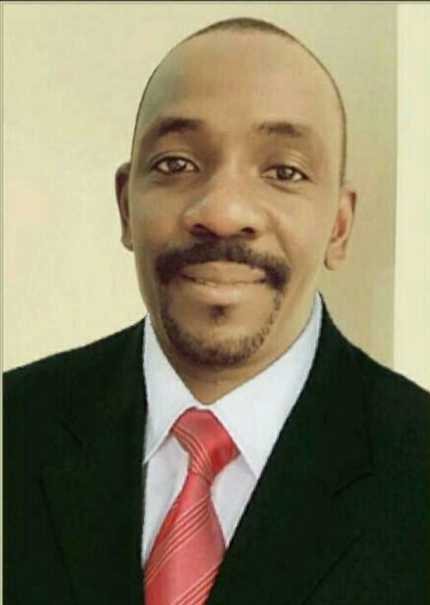
CURRICULUM VITAE
BIO – DATA
Name : Masasi
Date of birth : 12th/Dec/1979
Gender : Male
Nationality : Ugandan
District : Mbarara
MaritalStatus. : Single.
Emai. : masasi.383403@2freemail.com

JOB NEED: HOUSE KEEPING SUPERVISOR, WAITER, RECEPTIONIST, CAR WASHER.

CAREER OBJECTIVE.
To be dedicate, committed and offer effective results, service oriented and commensurate with the professional code of conduct and the organization policies stipulated.
KEY QUALIFICATIONS
I completed a diploma in Education from Kyambogo University,and a Super Class one (1) Certificate in Project Planning and Management (PPM)attainedat MakerereUniversity.
EDUCATION BACKGROUND
Year | Institution | Award
1999 | KagongoParents School | U.C.E
2002 | Kitagwenda High SchoolU.A.C .Ep
2004 | KyambogoUniversity. Diploma (Education)
2008 | Makerere University. Certificate (Project Planning &Management

WORKING EXPERIENCE.
2007- Worked as Stores and Records Officer Calender Hotel
2009-2012- Worked as Mananger with Calender Hotel
2013- Join UN missions in Uganda Rwenzori region ( worked as cottage Garden Flower / Compound overseer).
2009- Worked as Compound / Flower Garden Attendant Green Cottage (Kampala-Uganda).
RESPONSIBILITIES:
* As a Flower & Garden Attendant am responsible for the appearance and maintenance of the garden areas, flower beds and compound in general.
* To learn how to choose the best flowers to create colorful combos and a wow-worthy flower garden.
* To care and maintain Main flower boxes, hanging baskets and annual plant beds.
* Responsible for maintaining flower garden areas at all seasons.
* To create a beautiful landscape following the flower garden design tips for own yard.
* Creating an amazing garden, including planting tips & gardening trends for small gardens, containers, shade plants etc.

PERSONAL ATTRIBUTES
- Vision driven
- Self – motivated
- Result driven
- Proactive
- Good listener and communicator
COMPUTER SKILLS
- All office Packages
- Accounting packages
HOBBIES
- Reading novels, news papers
- Listening to new ideas
- Making friends

LANGUAGE
Language spoken written
English Excellent Very good
Luganda Excellent Very good
Arabic Fair Fair

IMasasi certify to the best of my knowledge and understanding that the information here given in this curriculum vitae is true description of my education and career.

