CURRICULUM VITAE
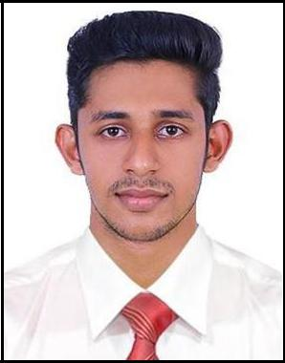

NISAM

nisam.383432@2freemail.com

Career objective:

Seeking a challenging and prospective career opportunity, which utilize the skills I possess by the virtue of qualification and working experience to this full, extend for the betterment of the company as well myself.

Personal Details:

Date of Birth | : | 08/Dec/1995
Sex | : | Male
Nationality | : | Indian
Education | : | S.S.L.C (Passed 2012)
 |  | Plus Two (Passed 2014)

Passport Details:

Place of Issue | : | Cochin
Date of issue | : | 07/Nov/2014
Date of expiry | : | 06/Nov/2024
Visa Status | : | Visit Visa

Language Known:

English & Malayalam

Technical Qualification:

Diploma in Automobile Engineering (Rajastan Vidhyapeeth University) From Christ College Irinjalakuda Kerala India On 2017

WORKING EXPERIENCE:

- 1 Year Working Experience as a Salesman in ITC limited, KK Agencies, Kerala India from June 2016 to July 2017

Computer Knowledge:

Operating System : Windows & Linux

Microsoft Packages : M.S Word, Excel, Power point, Outlook etc.

Designing : Adobe Photoshop Knowledge in Computer Hardware

Driving license Details:

Country | : | India
Blood Group : |  | O+ve

Skills:
- Good Communication Skills.

- Easily negotiate with other people.

- Have high level of persuasiveness.

- Can work effectively in team, as well as individually.

- Have good inter-personal skills.

Declaration:

Sir, I hereby declare that the above-mentioned information is correct and complete to the best of my knowledge and belief.

