RESUME
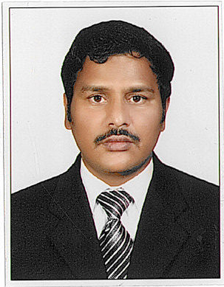
Name: Ahemad
Dubai
U.A.E.
Email : ahemad.383475@2freemail.com

Career Goal :
To grow with the Organization contributing effectively toward the excellence through self- driven motivation, sincerity and hard work and seeking for opportunity in Accounts & Finance with your repute organization.

TOTAL EXPERIENCE (10YEARS)
Organization:
Company : Emirates Trading Agency L.L.C. M&E Division, Dubai, UAE.
Position : Assistant. Accountant cum Document controller and Data Entry
Duration : 20.06.2007 to 31.12.2017
Reporting to : Senior – Finance, HR and Accounts

Job Profile:
Responsible to book all the invoices in ERP Software “Xpedeon”, “ Orbits”, and process payment in “ SAP” for suppliers (Internal & External) for 5 division running more than 20 Projects.
Assignments / Responsibilities:
- Processing of Suppliers invoices, booking of Direct and Indirect Expenses.
- Checking the certification of supplier’s invoices with respect to LPO, Delivery Note.
- Balance Reconciliation with Suppliers and Inter Division Statement.
- Preparation of manual cheque payment Suppliers & Sub Contractors.
- Erp reports like verification of indent, pending LPO, Vendor wise LPO report.
- Maintaining office file records of confidential Information.
- All Cheques Entry and reports made for SAP.
- Suppliers call attended and meeting.
- Performed accounts payable functions for construction expenses.
- Managed Vendor accounts, generating weekly on demand cheques.

Significant Achievement:
Recognized for performance excellence and awarded with a promotion within a short time of joining the Organization.
Academic Qualification:
- S.S.L.C. PASSED
Computer Skills:
- Micro Soft word, Excel, Access, Power Point, Outlook Express, Microsoft Windows and Microsoft Office.
- Type Writing
- SAP – FICO Module
- Handling ERP Software – Orbits &Xpedeon

Personal Details:
Religion : MUSLIM
Nationality : INDIAN
Marital Status : MARIEED
Date of Birth : 25.01.1982
Visa Expiry Date : Visit Visa
Language Known : Tamil, English, Urdu, Hindi,

I solemnly declare that all the details given are true the best of my knowledge,

