B.PHARMACY: RESUME CV

NAZEER

EMAIL: nazeer.383489@2freemail.com

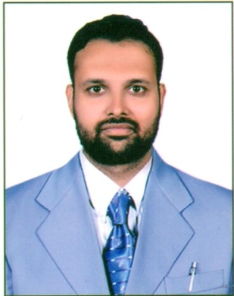
OBJECTIVE
To work in an organization which provides me an opportunity to enhance my qualities, show my abilities and grow along with the company.
EXPERIENCE
I have 5 years of working experience as a Pharmacist.
- Working as a pharmacist at Al-Salhi Pharmacy in Oman (Suwaiq) since January 2016 to April 2018.
- Worked as a Pharmacist at Fazal pharmacy from 2012 (May) to 2014 (December).
Job responsibilities with Al-Salhi Pharmacy-Senior Pharmacist:
- Providing outstanding customer service to patients.
- Effective in the stocking and dispensing of medicines; highly accurate in description filling, drug administration and patient counseling.
- Constantly noticed for the vast improvement attained in the drug-inventory management system.
- Skilled in cross selling.
- Have experience in managing retail pharmacy.
PROFESSIONAL QUALIFICATION
- Bachelors in pharmacy with from Deccan school of pharmacy, Hyderabad, affiliated to Jawaharlal Nehru technological university, Hyderabad.
ACADEMIC QUALIFICATION
- Intermediate from Sri Chaitanya Junior kalasala, Hyderabad.
- Secondary school certificate from Indo English high school, Hyderabad.
ADDITIONAL QUALIFICATIONS
- Qualified HAAD Pharmacists Examination.
- Qualified Saudi Council For Health Specialties (SCHS) exam.
- Completed Dataflow with Barcode - H005-VR-15-048015.
- Licensed pharmacist for Oman Medical Speciality Board (OMSB) License no: 2887.

PERSONAL SKILLS
- Fluent in Speaking Arabic and English.
- Comprehensive problem-solving abilities.
- Good communication skills.
- Hardworking, creative and a good team player.
- Self-motivation and passion to succeed.
COMPUTER AND TECHNICAL SKILLS
- Programming languages: C, C++
- Database technologies: MS Access
- Microsoft office suite: MS office (Word, Excel, POWER POINT)
- Operating systems: Windows 2000, XP, Vista, Win 07

PERSONAL INFORMATION
- Nationality : Indian
- Date of Birth : 31 July 1989
- Marital Status : Married
- Languages : English, Arabic, Urdu.
DECLARATION
I hereby declare that all the above Information is true and correct to the best of my knowledge and belief.

* References available on request.

