CONTACTS

Steven.383597@2freemail.com

SKILLS

Team Work ⬇⬇⬇⬇⬇

Inter-personal ⬇⬇⬇⬇⬇ Comm.

Active ⬇⬇⬇⬇⬇

Listening

Customer ⬇⬇⬇⬇⬇ Service

Time ⬇⬇⬇⬇⬇

Management

LANGUAGES

English

Hindi

Malayalam

CURRICULUM VITAE
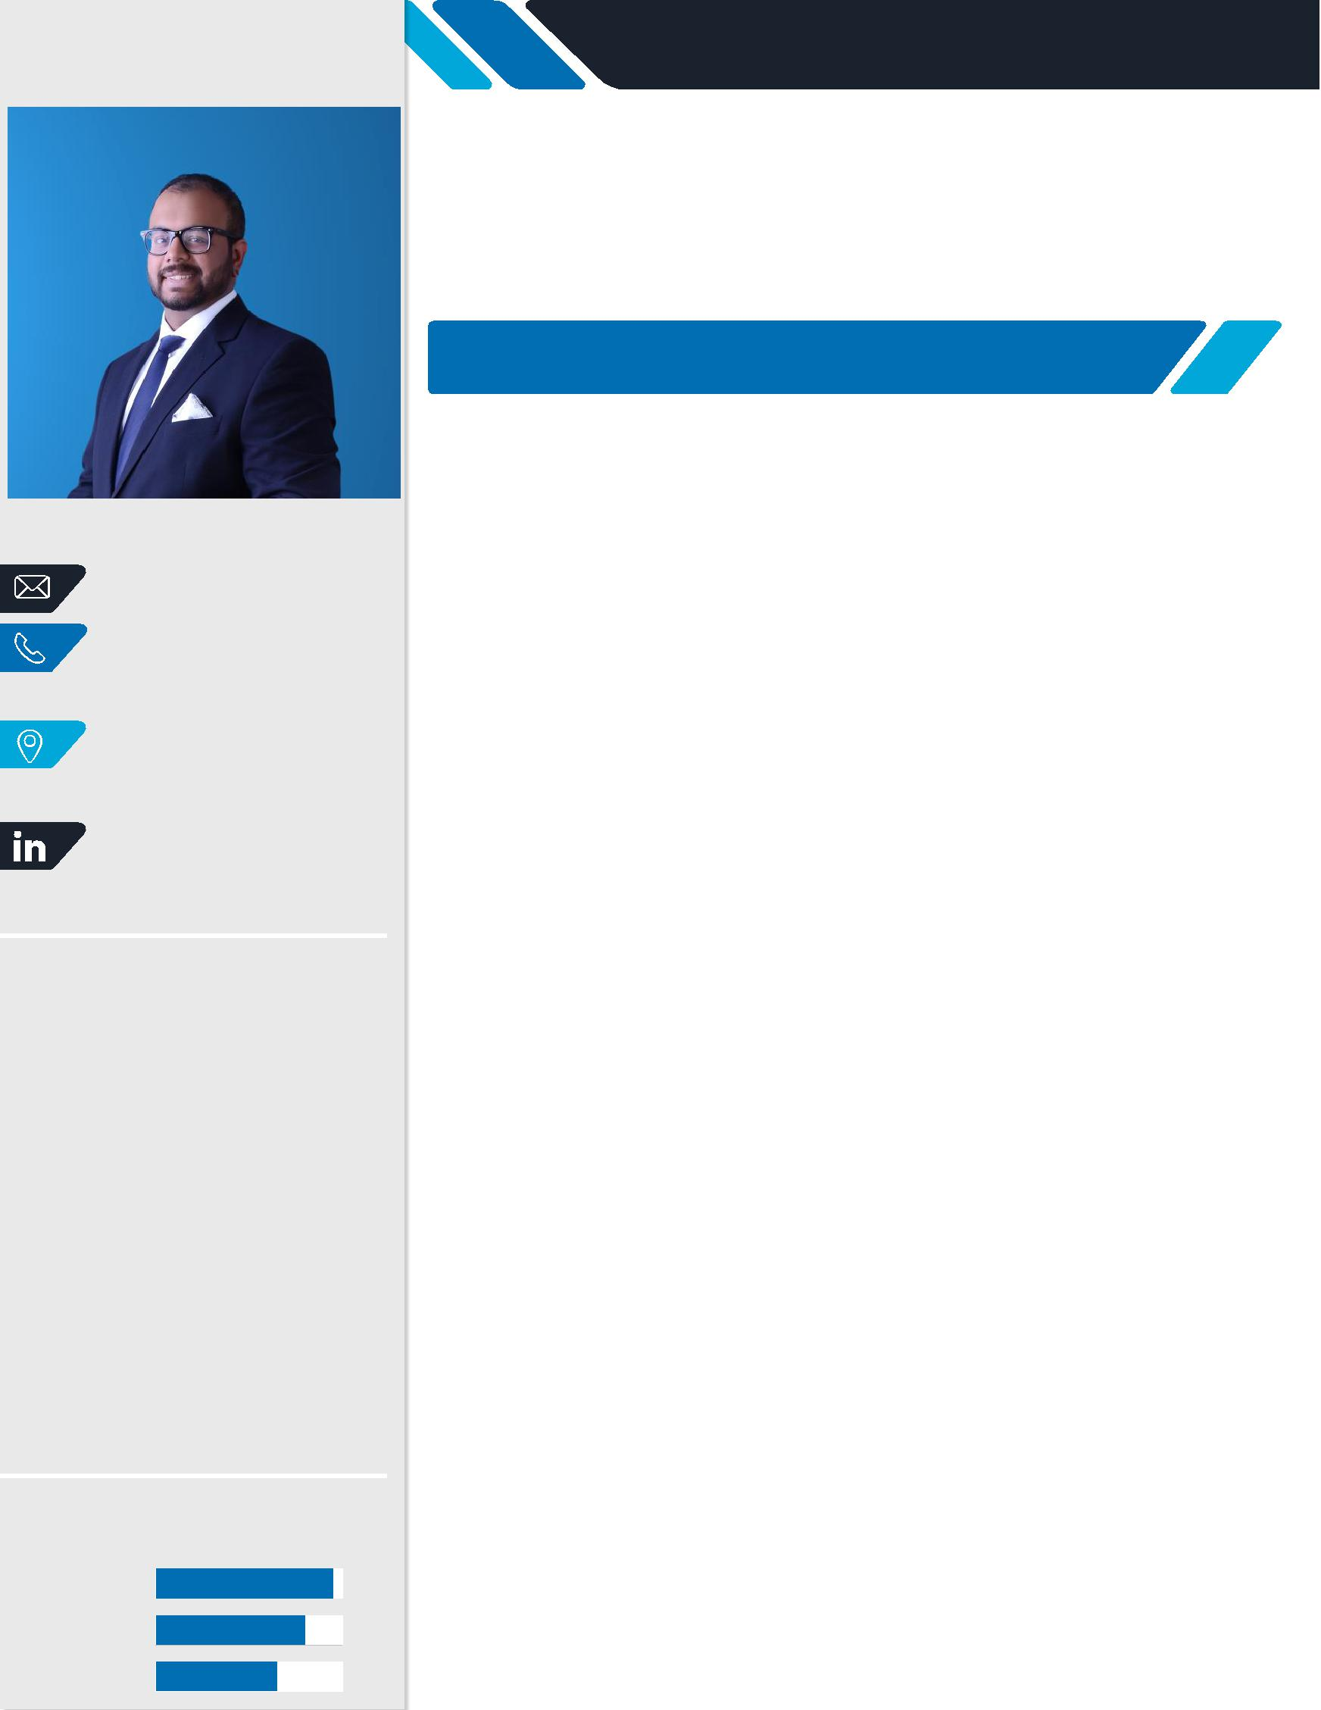

STEVEN

GRADUATE, ELECTRICAL & ELECTRONICS ENGINEERING

Professional Objective: A challenging assignment that provides an opportunity to contribute to organizational goals through continued development of communication, industry knowledge, problem-solving, decision-making and presentation skills.

EXPERIENCE

LOGISTICS BUSINESS DEVELOPMENT | May 2016 – Dec 2016
JECL LOGISTICS, JUMBO GROUP – DUBAI, UAE

- Support business development of Third Party Logistic Solutions

  - Gathering and recording relevant details of potential customers in company database.

  - Telemarketing activities to understand customer business requirements and introducing company offerings in terms of third party logistic solutions.

  - Arrange customer visits/meetings with senior managers to discuss possible ways of matching customer requirements with our logistic solutions.

  - Internal discussion with senior managers on how to translate customer needs to viable business opportunities for the company.

  - Handover the opportunity to the tendering team for further action.

- Supervision of warehouse goods inbound activity

  - Review of incoming documents such as invoices, delivery notes and custom clearance papers.

  - Arrange cargo off-loading and physical receipt of goods into warehouse.

  - Inspection and physical verification of received goods against the shipping documents.

  - Communicate with head office on the receipt and request for goods receipt entry in the system.

  - Arrange labelling of the received goods with GRN code and storage at the allotted location.

INTERN Aug 2015 – Jan 2016

SANBOOK QUALITY CONSULTANCY SERVICES – DUBAI, UAE

- Support business development of PMP certifications

  - Telemarketing activities to promote PMP certification business.

- Support QMS, EMS and OSHAS Audit inspections

  - Participated in pre-audit briefing by senior auditors on the methods and desired outcomes.

  - Opening meeting with customer to explain confidentiality, sampling and objective evidence.

  - Review of Quality Manual, Quality Policy, Quality Objectives (KPIs) and procedures.

  - Review of Training records, Internal Audit Reports and Non-Conformance Reports (NCRs).

  - Review of customer feedback/complaints and instrument calibration reports.

CURRICULUM VITAE

  - Closure meeting with the customer to explain non-conformance and possible improvements.

- Exposure to QMS, EMS and OSHAS standards

  - Attended awareness sessions on ISO standards and their implementation

EDUCATION

MASTERS IN INTERNATIONAL BUSINESS | 2017 – Present
MACQUARIE UNIVERSITY
SYDNEY, AUSTRALIA

B.E. (HONS) ELECTRICAL & ELECTRONICS ENGINEERING

BIRLA INSTITUTE OF TECHNOLOGY AND SCIENCE (BITS-PILANI) DUBAI CAMPUS, UAE

CBSE AISSCE

OUR OWN ENGLISH HIGH SCHOOL

SHARJAH, UAE

2011 – 2016

2005 – 2011

EXTRA CERTIFICATIONS

- IELTS - Score (7.5 / 9.0)
- GMAT - Score of (570 / 800)

OTHER

- Holds a valid UAE Driver’s License (issued in 2011)

