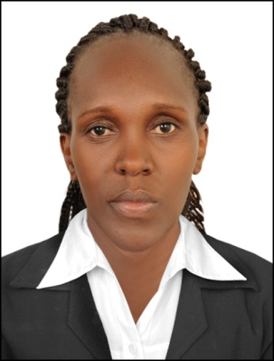
CURRICULUM VITAE

PERSONAL INFORMATION

NAMES : Judy
NATIONALITY : Kenyan
VISA TYPE : Employment visa
EMAIL : judy.383605@2freemail.com

Position: Camera operator and video editing

PROFILE
Dedicated and energetic professional media person with eleven years extensive experience in Video shooting, editing and photography. I am well exposed to digital world and capable of operating any digital professional camera do proper lighting and Am advanced in latest editing software packages thus making appealing edits for advertisement and commercial purposes.

WORK EXPERIENCE

5th April 2017 to date Hilton Jumeira Dubai
Position: Photographer/Videographer

In my current position of company camera operator am in-charge of events coverage.
capturing, retouching, printing and framing photographs, video shooting, compiling edit footage for social media.

Jan 2014 to Feb 2017 Royal Media Limited – Nairobi Kenya
Position: Camera operator

I worked for Citizen Television which is one of the many brands of Royal Media Company, within this period I fine tuned my skills in camera operation and I successfully participated in news gathering and studio production earning a promotion to a senior camera operator position.

Duties and responsibilities
- Assembling and setting equipments
- Planning, preparing and rehearsing scenes
- Following camera scripts
- Creatively framing and capturing Actions
- Respond quickly to directions
- Liaising with lighting and technical team

June 2010 to December 2013 Media Max Limited – Nairobi Kenya
Position: Video editor

My proficiency in Avid, Final cut, Adobe premiere, Adobe After effect and Adobe photo shop gave me a good opportunity to create a compelling image of the company earning high revenue for the owners.

Duties and responsibilities
- Editing commercials, and promotional materials for the company
- Responsible for the final edit product colour correction, audio mixing and graphics designing

January 2008- May 2011
Freelance
Duties and responsibilities
- Created short movies for music bands, fashion design events and commercial companies
- Managed the entire process of creating a video from production to post production with the organization team
- Worked on time basis and worked independently
- Directly communicated with clients to meet their need
- Edited videos for different commercials

Education & Professional Qualifications:
- Dec 2007 Diploma in TV / Video Production. Mt. Kenya University
- June 2007 Africa College of Aviation Management Complete certificate in Computer packages – MS Office, MS word
- Feb 1994- Nov 1997 Kenya Certificate of Secondary Education. (KCSE).Gichuru High School

- Referees: to be provided upon request.

