FAWAD .CV

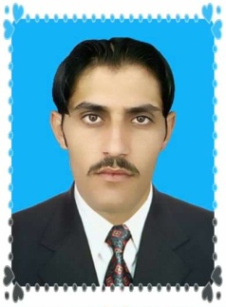
PERSONAL INFORMATION
FULL NAME: FAWAD
COUNTRY : PAKISTAN
RELIGION : ISLAM
E-mail: fawad.383635@2freemail.com
Date of birth 02/03/1994
Marital status: MARRIED
EDUCATION ADN QUALIFICATION
MATRIC 2010 BISE MALAKAND
INTERMIDEAT: 2011 BISE MALAKAND
LANGUAGAES
1: Pashto: Good Native language
2: Urdu: Good National language
3: English: Reading, writing and conversation
1: SKILL EXPERIEANCE
1: 6 MONTHS PLUMBING VERIFIED DIPLOMA HOLDER FROM SKILL DEVELOPMENT COUNCIL PESHAWAR (CERTIFICATE ATTCHED)
2: 6MONTHS ELECTRICIAN VERIFIED DIPLOMA HOLDER FROM SKILL DEVELOPMENT COUNCIL PESHAWAR (CERTIFICATE ATTCHED)
2: COMPIUTAR SKILL:
1 MS OFFICE 2 INTERNET 3 WINDOWXP 4 WINDOW7: 6 MONTH DIPLOMA FROM CALYPSO SYSTEM PVT REG (CERTIFICATE ATTCHED)

