CURRICULUM VITAE
PERSONAL DETAILS

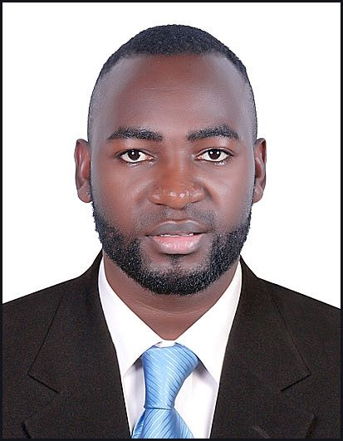
Name Douglas
Gender Male
Height 5 feet
Weight 70 Kg
Marital Married
Nationality Ugandan
Language Fluent English and Uganda
E-Mail douglas.383664@2freemail.com
Availability Immediate
Visa Status Visiting Visa

CAREER GOALS AND ASPIRASTIONS

My previous profile is to obtain a position in any challenging organization that allows me to contribute effectively my knowledge, skills and interest with progressive approach in pursuing further education and personal growth. a diligent, hardworking, confident and determined person am easily able to work under littler no supervision and take on my tasks courageously. I love challenges because they help to make me sharpen my skills also a good team player and humble personality.

MY KEY ENTERPRENUERSHIP SKILLS INCLUDE

- Well versed with product knowledge and market ability
- Confident, dynamic able to relate to people with diverse cultural background.
- Cooperation with co-workers and employers
- Fast learner able to adapt to any environment within a very short duration.
- Focused and responsible with very good organizational ability.
- Self driven able to work under pressure and ability to attain goals and objectives

EDUCATION

2009 - 2012 Diploma in Hotel Management in YMCA Institute
2008 – 2009 - Advanced Certificate (High School Certificate) – Aghkan 2004 – 2007 – Ordinary Certificate – Kampala High School

WORK EXPERIENCE

POSITION : COOK
COMPANY : KAMPALA INTERNATIONAL HOTEL, KAMPALA, UGANDA DURATION : 1 YEAR (2012 to 2013)

POSITION : COMMI 2
COMPANY : CHICKEN TONIGHT, KAMPALA, UGANDA DURATION : 1 YEARS (2013 to 2014)

POSITION : COMMI 2
COMPANY : KFC , GARDEN CITY , UGANDA DURATION : 1 YEAR (2014 to 2015
POSITION : COMMI 2
COMPANY : TERMINAL BURGER, BAHRAIN DURATION : 1 YEAR (2015 to 2016)

COMMI 2 – DUTIES & RESPONSIBILITIES

- Using various types of dough blends
- arrangement of Kitchen
- Managing Busy Time
- Opening and Closing of the restaurant
- Working under pressure
- Using various types of cleaning detergents
- Making various types of pizzas standards
- cleaning and working out with all machines in the restaurant
- Time Keeping
- Food Safetyand Standards / Sanitizing
- Working out with the dish wash area
- Topping Cuttings

POSITION : COMMI 1 (KITCHEN SUPERVISOR)
COMPANY : THREE LINES GROUP OF COMPANY BAHRAIN DURATION : 2 YEARS (2016 to 2018)

COMMI 1 – DUTIES & RESPONSIBILITIES
- Arrangement of the Kitchen
- Clean & Working out with all machines in the restaurant
- Food Safety and Standard / Sanitizing topping cuttings TECHNICAL SKILLS
- Mashed Potato and baked potato
- Sauces
- Crape
- Burgers
- Order making and processing
- Dishes
- Work Area arrangement
- Speed or Work and First Learner
- Pastry Maker

Declaration
I’m hereby declaring that all above given statements it true and correct to best of my knowledge.
REFEREES: UPON REQUEST

