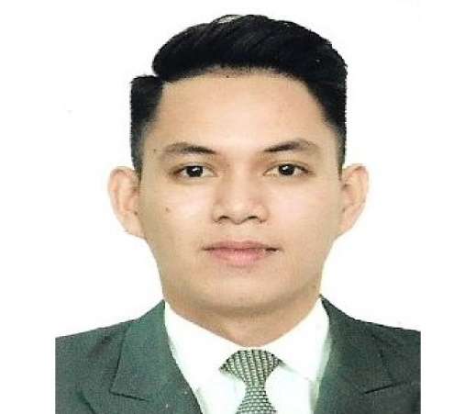

NOLAN
Nolan.383674@2freemail.com

ObJective

To obtain a responsible and challenging job and opportunity where I could practice my knowledge and develop my personality as a career person while utilizing my skills as a bartender to bring out the harness and the best of my potentials for the glory of God and for the benefit of my employer, the community and myself in preparations for the future advancement for the top management.

EDUCATIONAL BACKGROUND

2012-2016Northwestern mindanao state university
BACHELOR OF SCIENCE IN HOSPITALITY MANAGEMENT
(Misamis Occidental)

2008-2012 Saint vincent high school
((Bonifacio, Misamis Occidental)

2003-2008 TaNgub central school
(Tangub City, Misamis Occidental)

PROFESSIONAL EXPERIENCES

06.2018-09.2018 FAUCHON PARIS
Mall of Emirates, Dubai
BARISTA

04.2016 - 06.2018 PRIVIS CORP. (GERRY’S GRILL bar and restaurant)
Ayala terraces,cebu city
Bartender
12.2015 – 03.2016 PRIvis corp. (Gerry’s grill bar and restaurant)
Ayala terraces, cebu city
Bartender (OJT)
11.2012 – 03.2013 PRIvis corp. (Gerry’s grill bar and restaurant)
Ayala terraces, cebu city
Service Crew (OJT)

PERSONAL INFORMATION

Age : 22
Date of Birth : November 6,1995
Place of Birth : Tangub City Misamis Occidental
Citizenship : Filipino
Religion : Roman Catholic
Weight : 75 kg.
Height : 5’9

