CURRICULUM VITAE
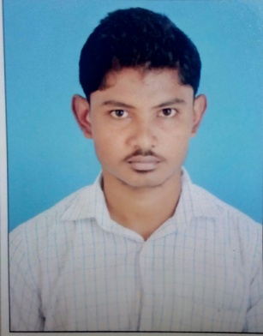
GUHAN
E-Mail: guhan.383682@2freemail.com
Visa Status: Visiting Visa

OBJECTIVE
A highly talented,professional and dedicated Civil Engineer.To Achieve high career growth through continuous process of learning for achieving goals and keeping myself dynamic in the changing scenario to become a successful professional and leading to best opportunity and am willing to work as a Civil Site Engineer in the reputed construction company.

EDUCATIONAL QUALIFICATION
- B.E.,in Civil Engineering from Arasu Engineering College, Kumbakonam under Anna University,Chennai passed out in the year of 2015 with aggregate of 6.44 out of 10.00 CGPA.

PROFESSIONAL EXPERIENCE
- Organisation:ANAND CONSTRUCTIONS
- Designation: Site Engineer
- Duration:September 2015 toNovember2017.

JOB RESPONSIBILITIES
- Site inspection for civil construction work and ensure that the work isas per the project specification and issued for construction drawing/final approved drawing from authorities.
- BOQ Preparation of civil works.
- Proper management of materials and workmanship.
- Ensure that all the works meets the stipulated quality standards.
- Coordinate with subcontractors for smooth flow of work.
- Carry out inspection and checking for all quality related procedures in the site and ensures activity at site per approved method statement and inspection test plan.
- Coordinate with the consultant’s representative and site in-charge for inspection and meeting about quality problems including closure of Non-compliance report.
- Day-to-day management of the site,including supervising and monitoring the site labour force and the work of any subcontractors.
- Develop method of statement for the activity including risk assessment and job safety environmental analysis and inspection test plan and checklist based on specifications of the project.

- JUNIOR ENGINEER to the concern of TNHB (Madurai) in the period of January 2018 to June 2018.

Project Name: Road work and drainage system.
Client: Tamilnadu Housing Board (state government project).

SOFTWARE SKILLS
- Design software:Auto CAD
- Proficient user of MS Office (Word,Excel).

PERSONAL TRAITS
- Team Oriented,Honest candid,Empathic and Hardworking.
- Judging and occurring situations and updating with new technologies.
- Creative and able to concentrate for extended hours.

PERSONAL DETAILS
Date of Birth : 29/11/1993
Gender :Male
Nationality : Indian
Marital status : Single
Languages known:Tamil and English (to write read and speak)
Temporaryaddress :Dubai
Visa status :Visiting visa
DECLARATION
I hereby assure that the above details are true to the best of
my knowledge.

