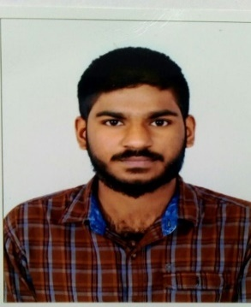
RESUME
AMAN

Email : aman.383710@2freemail.com

OBJECTIVE:
To work in challenging and creative environment where i can put in any best for the development of the organization and in turn develop my personality.

ACADEMIC PROFILE

Course | Institution | Passing of Year | Percentage
S.S.L.C | Govt. School, Jokatte | 2011 | 74%
P.U.C | Badriya PU College, Mangalore | 2013 | 84%
BBM | SDM College, Mangalore | 2016 | 52%

OTHER QUALIFICATION:

- Basic in Computer
- Tally

PROFESSIONAL EXPERIENCE (INDIA):

SALES CO-ORDINATOR(JUNE 2016-JUNE 2018)
I have a total of two years of experience as sales co ordinator.I started my career in hyper market. My responsibilities are:
- Managing all the sales related activity of the company.
- Handling customer enquiries and providing high quality of service.
- Tracking sales orders and ensure that they are scheduled and sent on time.
- Organizing sales promotional campaigns.
- Responding to sales queries.
- Resolving any sales related issues with customers.
- Organizational development and planning.
PERSONAL INFORMATION :

Gender : Male

Date of Birth : 05-05-1996

Religion : Muslim

Nationality : Indian

Languages Known : English, Hindi, Kannada and Malayalam
Residing City : SHARJAH
Passport Details:
Passport Issue : 22/07/2016
Passport Expire : 21/07/2026
Place of Issue : Bangalore
visa status : visit visa
Key Personal Skills:
Effective communication, dynamic leadership, smart relationship management, cultural adaptability, inquisitive nature, innovative and creative, team work and task management, work under any pressure, good convincing power, experience in various departments of business, strategic development, stress management, time management, performance evaluation.
Declaration:
Above information is correct in my knowledge, if you favour me with an appointment I shall do my best to work to the entire satisfaction of my superiors.

