Curriculum Vitae of Kamran

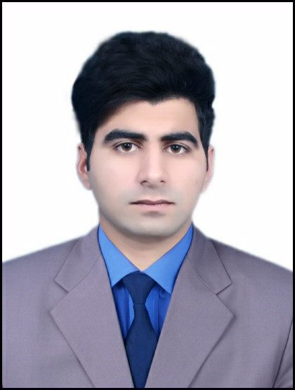 | Abu Dhabi, United Arab Emirates  Email: kamran.383726@2freemail.com  Date of Birth: 28th December 1995  Marital Status: Single  Nationality: Pakistani  Visa status : Employment visa  Holding UAE valid driving license

A qualified and experienced person having exposure to multiple facets of business in Retail, Manufacturing and Banking Sector. Looking forward to acquire a challenging position where I can utilize my education skills and experience in the best possible way towards achieving the growth and development of the organization.
KEY Skills
- Excellent Presentation and Communication skills.
- Excellent Customer Service Skills.
- Multi-tasking and well organized.
- Good knowledge of Human Capital and General Administration.
EDUCATION
CERTIFICATE/DEGREE | SESSION | BOARD/UNIVERSITY | Obt/Total Marks
S.S.C (Arts) | 2015 | Board of Intermediate & Secondary Education Mardan | 603/1100
Work Experience

Present working :Working as a Cashier in Al Ghweifat market.

Responsibilities:

1. Handling all the cash transactions.
2.Checking daily cash accounts
3.Maintaining daily, weekly and monthly report of transactions.

- Perform any other duties or tasks as required or instructed by the line manager to support the smooth operation of the branch.
Sales Associate:
1 Year experience as a Sales Associate in Al Madina shopping mall kamra,Attock,Pakistan
COMPUTER SKILLS
- MS Office
- Internet and E-mail
- In- page
- Windows installation
LANGUAGES
- English – Business Level Fluency
- Urdu – Fluent
- Pushto – Native
- Hindi – Speaking Skills
Conclusion
Utilizing my qualifications, knowledge, skills and experience I am confident that I will provide valuable contribution towards the growth and progress of the organization. Hope you will consider my candidature for a suitable position in your esteemed organization.

