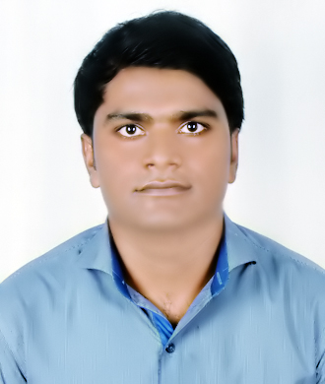
Chandra

Email: chandra.383767@2freemail.com

OBJECTIVE

Work with diligence for the development of an organization by applying myknowledge and
Interpersonal skills.

WORK EXPERIENCE

Worked as full time Hospital Pharmacist in Unique College of Medical Science & Hospital Pvt Ltd, Rajbiraj, Nepal from 2010 to 2018.

EDUCATIONAL QUALIFICATIONS

SLC from HMG Nepal in 2002.

10+2 from HSEB Nepal in 2004.

B.Pharma from RGUHS, Bangalore in 2010.

PROFESSIONAL QUALIFICATION
Bachelor in Pharmacy (B.Pharma) from Rajiv Gandhi University of Health Science,
Bangalore, India in 2010.

LICENSEDETAILS

DHA Eligibility Letter

Registered inNepal PharmacyCouncil

VISA TYPE- Visit

PROFFESIONAL SUMMARY

Patient service oriented pharmacist with eight years of experience as Hospital pharmacist having strong background in clinical pharmacology and patient medication therapy. Good track record of maintaining positive relationship with patient, customer and medical professionals.

PROFFESIONAL SKILLS

- Prepares medications according to physician orders.

-Dispenses of medications by compounding, packaging, and labeling.

- Provides necessary pharmacological information of drugs to concerned one.
-Reporting drugs' adverse reactions
-Maintaining the record of patient’s drug therapy and pharmacy care plan.
-Storage of drugs and biological products.

-Drug related Documentation of controlled substance.

-OTC Product and recommendation of alternate medicine.

-About Nutraceutical and Herbaceutical.

-Checking pharmaceutical stock to assess inventory level; placing orders; removing outdated drugs

YEARS OF EXPERIENCE

Eight years of experience as Hospital pharmacist.

PERSONAL SKILLS

Good communication, interpersonal, analytical and organizational skills.

Ability to work harmoniously in a multi-cultural environment.

Energetic and self-motivated having strong work ethics and taking the
Ownership of duties and responsibilities.

OTHER SKILLS:-
Basic knowledge of computer, Internet.
PERSONAL DETAILS
Date of Birth: 30 Dec 1985

Sex: Male.
Marital Status: Married
Nationality: Nepalese
Language known: English, Hindi, Nepali, Maithili.
Hobbies: Reading, Music and Interacting with people.

DECLARATION
I do hereby confirm that all above information is true to the best of my knowledge and belief.

