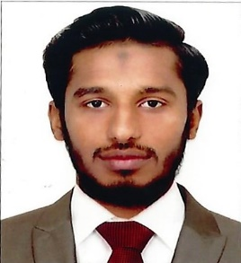 MIRZA
Email: mirza.383774@2freemail.com
Personal Profile:
I am Friendly and Respected Customer ServiceCoordinator with a passion for Business. My studies and previous work experience are all in these. And I am currently looking for my carrier in a more challenging role. I have excellent communication skills which have enabled me to build strong relationship with customers, colleagues, Higher officers. I have previously managed a number of customers and give successful solutions. And I have the excellent ability to coordinate with management and other team staffs.
Education Achievements:
- Master of Islamic Studies completed in B.S Abdur Rahman Universityand placed in First class scored as 85.92% on 2018 in India at Chennai.
- Bachelor of Islamic Studies completed in B.S Abdur Rahman University and placed in First class scored as 78.92% on 2016 in India at Chennai.
- Higher Secondary completed in Crescent Private school and placed in First class scored as 69.75% on 2013 in India at Chennai.
- Primary Education Completed in St. Xavier Matriculation Higher secondary school and placed in First class Scored as 70% on 2010 in India at Tirunelveli.
Additional Qualification:
- Bachelor of Business Administration in University of Madras on 2016 and Placed in First class scored as 78.64% in India at Chennai.
- Master of Business Administration in University of Madras
- Diploma in Customer service Aspirar Aviation Academy.

Work Experience:
- Customer service agent in Chennai International Airport appointed by Air India Air Transport Service ltd. From July 2016- Dec-2016.
- Administrative Officer & Customer Service Co-Ordinator in Habitat Serve Cleaning Services LLC. In Dubai at Deira. From the date of November 2017 - August 2018.

Personal Attitude:
- Customer handle with friendly & Respectively
- Ready to work hard and Smart
- Co-operative with Management
- Verbal communication skills in English & Arabic
- Learn new skills from others
- Punctuality in Everything.

Personal Details:
- Gender : Male
- Marital Status : Single
- Date of Birth : 01/03/1995
- Hobbies : Sports & Learn Skills

I am here by Declared that all the details are true to the best of my knowledge.

