SULTHAN
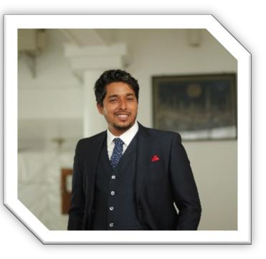 Sulthan.383856@2freemail.com

“I look forward to secure a challenging position as an Engineer in an esteemed organization where individual talent, dedication, sincerity & hardworking will be acknowledged and to use my skills in organizational development and constantly learn with open mind”

2.0

ULCCS PVT Ltd,Kozhikode
June 2016-Present

STRUCTURAL DETAILER
AUTO CAD REVIT STAAD

2.0
GULF TECH MEP &TRAINING CENTER LLP,THRISSUR
June 2016-Present

ME STRUCTURAL ENGINEERING
2014 -2016
Anna University , Chennai
CGPA 7.43

Completed gulf job training in Gulf Tech MEP training center LLP

PRO
Completed professional certificate course in AUTO CAD
Completed professional certificate course in structural design
Completed professional certificate course in Rebar detailing

LEADERSHIP PROBLEM SOLVING DECISION MAIKING DRIVE FOR RESULT LISTENING GRASPING COMMANDING

Bill of quantities

Site Super- vision

Project management

Me being an
Engg

Resource manage- ment

RCC
design
Reports

Construction of protection structures like Culverts, Slab
,retaining wall and dry rubble masonary
Preparation of Quotation, Invoice &Estimation of certain projects
District flagship improvement programme –Hill highway
Kannur,Kerala
Co-ordinate work party with safety precautions and measures
Coordinate with Consultant, Project Management Team of Main-Contractors, Sub-contractors & other service contractors

Controlling, coordinating and supervising the work party and work site
Preparing steel and masonry bill of quantity
Bar Bending schedule
Making of sectional drawings of structural elements
Conduct meetings with the client to brief about the progress of work
Review & approve project close out documents as per the specification
Prepare steel shop drawing for miscellaneous steel

Ruwais housing complex
UAE

Culvert for Road Crossing kakkathode,kannur

DFIP Hill highway Kannur

Commercial complex project kundayithode,Calicut

FOOTBALL CURRENT AFFAIRS MUSIC

