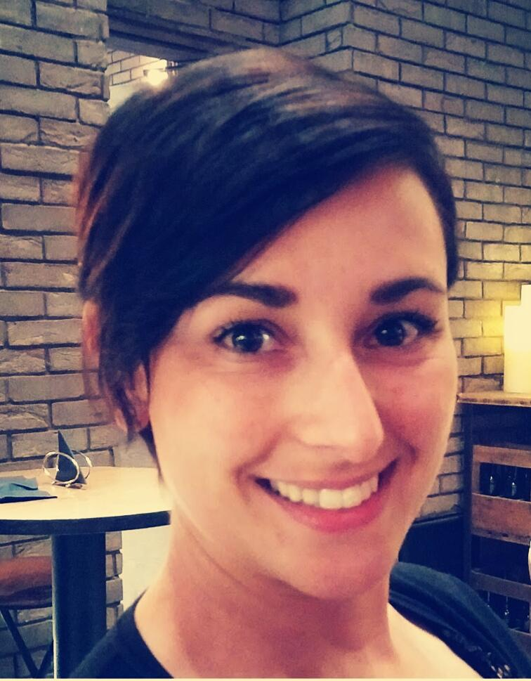

**CHIARA**

Nationality: Italian

[Chiara.383871@2freemail.com](mailto:Chiara.383871@2freemail.com)

**QUALIFICATIONS**

2004- Diploma in Hotel management school (Italy)

2004- Catering services certification (Italy)

2008- Food Science and technology laurea (bachelor’s degree, Italy)

**WORKEXPERIENCE**

2000-2009: head waitress (Italy)

2009-2013: shop assistant in pizza and bakery shop (Italy)

2013-2017: business development (my own business in Italy)

2013-today: supervisor (refresh deluxe café Dubai)

**INTERNSHIP**

2007: Rigoni di Asiago (high-quality food from ORGANIC farming)

2008: Mieli Thun (worldwide business of honey products)

**ABILITIESANDSKILLS**

I fell in love with food and beverage when I was a young girl. I’ve studied and always worked in hospitality to improve my knowledge. This is the sector when I never felt bored or tired to work in and where I think I’m really brilliant!