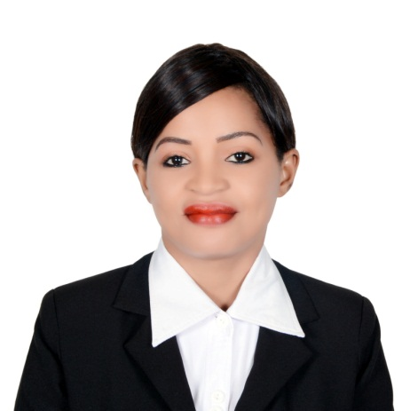
Christine

Email:- christina.383882@2freemail.com

AREA OF STREGTH

- High integrity, self-confidence and Customer service orientation.
- Effective listening, self-motivated, excellent planning and organizational capability.
- Great communicator and ability to provide timely and satisfactory resolution with a view to customer acquisition and retention.
- Creative thinker, focused on bottom line results, excels in multitasking and prioritizing work assignments

PROFESSIONAL ACHIEVEMENTS

Top performing Sales Associate with three years’ experience in retail sales and a reputation for exceeding performance benchmarks. Highly skilled at leveraging consultative sales techniques to upsell products and exceed sales targets. Demonstrated leadership skills that align teams and strengthen brand loyalty through exceptional customer service. Seeking to apply diverse sales experience to take next career step with a retail organization dedicated to providing world class customer service and producing strong team leaders.

WORK EXPERIENCE
Company: Safari Fashion
Duration: March 2015 to Jan 2018
Position: sales Associate
Location: U.A.E, Abu Dhabi

Job Description

- Approach browsing customers and initiate conversations to determine buying preference.
- Maintain constant presence on sales floor to address customer’s needs.
- Recommend appropriate items and direct or lead customers to selections.
- Assist customers with trying on items, finding appropriate sizes, and completing purchase
- Sign customers marketing list and inform of upcoming promotions or customer events.
- Prepared for promotions by rearranging stock, adding signage and tagging merchandise.
- Inquire about buying experience, item preference, and future purchase.

Company: Spar Lounge
Duration: 2010 Mar to 2014 Dec
Position: sales executive/Receptionist
Location: U.A.E, Abu Dhabi

Job Description

- I won Sales Person of the Year for five consecutive years having exceeded all quarterly sales targets by an average of 25% over a sixty- month period
- Interface with customers to identify purchasing needs and direct them to appropriate section.
- Recommending best and safe cosmetic lines to customersRead beauty magazines and updated knowledge on skin care
- Provided customer service over 30 people in each shift and booked appointment over the phone and in person.
- Responded to 30-50 inbound calls per day in high call volume environment.
- Helped increase profits by devising and recommending a variety of promotions and customer incentives which significantly increased patronage.
- Developed a new system for generating sales leads which was implemented in the company and resulted a huge improvement in sales performance

Company: Kenya Safaricom Telecommunication
Duration: 2007 June to 2009 July
Position: customer service/Sales
Location: Kenya, Mombasa

Job Description

- Promote sales by suggesting products to customer, providing Information and helping in choose the product
- Handle customer queries at the front desk for both prepaid and postpaid sales, services and products.
- Making customer aware of any schemes, discount and promotional offers.
- Meet targets, generate business performers post sales activity and reduce company costs
- Manage time scales and service level agreements to make sure crucial components are delivered on time.

EDUCATION AND PROFESSIONAL QUALIFICATIONS

Alison Online LearningJan 2015 – Feb 2017 - Diploma inCustomer Service and Sales Management.

Abu Dhabi Municipality Training - Oct - 2013 - Certificate for good Customer Service and hygiene
KEY SKILLS
- Bilingual fluent both English and Arabic and highly skilled in greeting customers service experience.
- Excellent interpersonal skills, able to stand for a long periods, effective time management and ability to stay calm in a stressful circumstance
- Highly presentable, outgoing, social and thrives in a very fast paced environment.
- Service minded, product knowledge, motivated seller and professional at all time.
- Excellent physical stamina and dexterity with capability to bend, stoop, reach out to grab objects above head level and work effectively in confined spaces.

PERSONAL DETAILS

Marital status: Single
Nationality: Kenyan
Availability: Immediately

