PERSONAL

INFORMATION
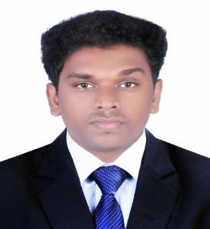

CAREER OBJECTIVE

EXPERIENCE

EDUCATION

TECHNICAL SKILLS

PROJECTS

INTERESTS

BIBIN

Bibin.383887@2freemail.com

Date of Birth : 05/09/1990

Marital Status : Single

Nationality : Indian

Known Languages : English,Malayalam,Tamil

Scouting for a progressive career in any area where my skills can be used in a reputed organization by contributing the best of my knowledge and experience to the organization.

• Amster Software Technologies 26/07/2017 - 31/08/2018

Team Leader

Worked as Team Leader in Amster software Technologies,Handled design of digital automated kiosk,Its Technical and Non Technical side,Marketing, Networking and Sales.

• Exodus 07/01/2015 - 31/05/2017

Marketing Coordinator

Worked as Marketing Coordinator in IT Department,handling marketing and Co ordination of labours.

• Godrej Intero Pvt.ltd 01/08/2013 - 30/11/2014

Junior Executive

Designing of interiors and the co ordination of team members

Jawaharlal Nehru Technological University,Hyderabad B.Tech,Electronics and Communication Engineering, 63.94%

Department of Technical Education Kerala State | 2013
Plus Two Technical Higher Secondary, 65% | 2008
Department of Technical Education Kerala State
10th from Technical High School, 66% | 2006
> Operating Systems: Windows,Linux,Apple
> Data base
> Web development: Photoshop,Html,Coral draw
> Additional skills: Machine Drawing,Auto Cad

Air Quality Monitoring System

A project for measuring the quality of air in industries has been developed with the help of embedded system.A number of highly sensitive sensors are used for detecting the amount of gases present in the atmosphere.LCD was used to display the readings.The project was tested giving necessary test conditions.

Black Box

A major project for recording the events in an automobile was developed for post crash data assessment for statistical evaluation of the accident.Event like speed,engine temperature,steering wheel position,brake level,RPM of the engine,gear position etc were determined.

- Any field i can build my career with my educational background and experience.

- Good in listening to others.

- To deal with people diplomatically.

- Solve comprehensive problems.

PERSONAL STRENGTHS

DECLARATION

- Confident,self motivated,responsible,creative and resourceful.

- Dynamic team player with leadership charisma.

- Good Communication skill.

- Fast learner,hardworking and friendly in nature.

I here by declare that all the above furnished information is true to best of my knowledge and belief.

