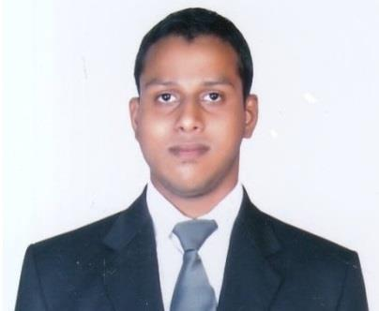
Rosario

Email: Rosario.383896@2freemail.com

OBJECTIVE

To contribute in the Customer Service by the process of continuous learning & research, exploring new avenues and improving existing ones

To excel in my chosen field by utilizing my skills and abilities when working in corporate and team-oriented environment.

Experience Summary

An IT professional with 1.5 years of experience in the IT industry.

Logistic specialist with 2.10 years of experience in Air Imports & Exports Freight Forwarding Services

PROFESSIONAL EXPERIENCE:

DHL Global Service Centre, Mumbai as Process Associate (Life Conex Monitoring Team)

From May 2015 – Mar 2018.

Job Profile

- Communicating & updating the customers via system or software entries.

- Assist DGF to provide Pre-alerts documents of the shipment for processing.

- Verify docs received from the DGF Origin.

- Verifies and corrects errors in data to ensure accuracy of completed work.

- Co-ordinate with the Origin port / airport agents with respect to cargo loading/discharging operations & other updates.

- Maintain records including problem documentation and action taken; file management logs and similar data.

- Monitor daily cargo movements and follow-up through computer Software.
- Generating reports in excel.
- Client co-ordination via call or email.

Advance Computer Services Ltd, Mumbai as Desktop Support Engineer.

From July 2012 to October 2012.

Job Profile

- Worked for ACS LTD Under IBM Contract in Glenmark Generics Ltd.

- Technical Support to the team/company via remote access or by call.

- Handled End Users Daily Basis.

- Good Knowledge of Troubleshooting Desktop’s & Printers.

Tata Consultancy Services, Mumbai as Application Support Engineer.

From July 2010 – January 2011.

Job Profile

- Application support to the project associated with Byzan systems.

- Installation of Citrix web application on Thin Clients.

- Drive Mapping for end users on the web application.

- Microsoft Outlook installation & accounts creation on exchange web server for end users.

- Remotely providing service, formatting & maintenance of PC’s & thin clients.

Siemens Information System Ltd, Mumbai as Trainer Desktop Engineer.

From October 2009 – March 2010.

Job Profile

- Pc/Laptop formatting & installation.

- Inventory records of pc peripherals.

- Coordinating with customers through system software’s for PC/Laptop issue.

- Individually done calls with end-user.

PERSONAL SKILLS

- Excellent verbal and written communication skills, willingness to learn, temperament suitable for teamwork, hard worker.

- Knowledge of Customer Support Executive.

- Coordinating with Clients.
- Good Knowledge & etiquettes of communication via phone calls, emails, internal system.

EDUCATION & ADDITIONAL QUALIFICATION

- Diploma In-flight & Ground Staff Services (Mahatma Gandhi University), Mumbai (2014).

- Microsoft Certified System Professional, Microsoft Certified System Administrator (2009).

- Maharashtra State Board Examination through Royal Junior College, Mumbai (HSC) (2008).

Strengths

- Hardworking.

- Always ready to learn new technologies & skills.

- Like to take responsibilities.

- Experience of working under pressure.

INTERESTS

Listening Music, Playing Football & Cricket, travelling in new places, new gadgets, exploring new places, indoor & outdoor games.

PERSONAL DETAILS
Date of Birth | : | May 31, 1990
Gender | : | Male
Nationality | : | Indian
Religion | : | Roman Catholic
Languages | : | English, Hindi, Marathi & Konkani
Marital Status | : | Single
Visa type | : | Visit

DECLARATION

I hereby declare that the above written particulars are true to the best of my knowledge and belief.

…………………………………………………..

