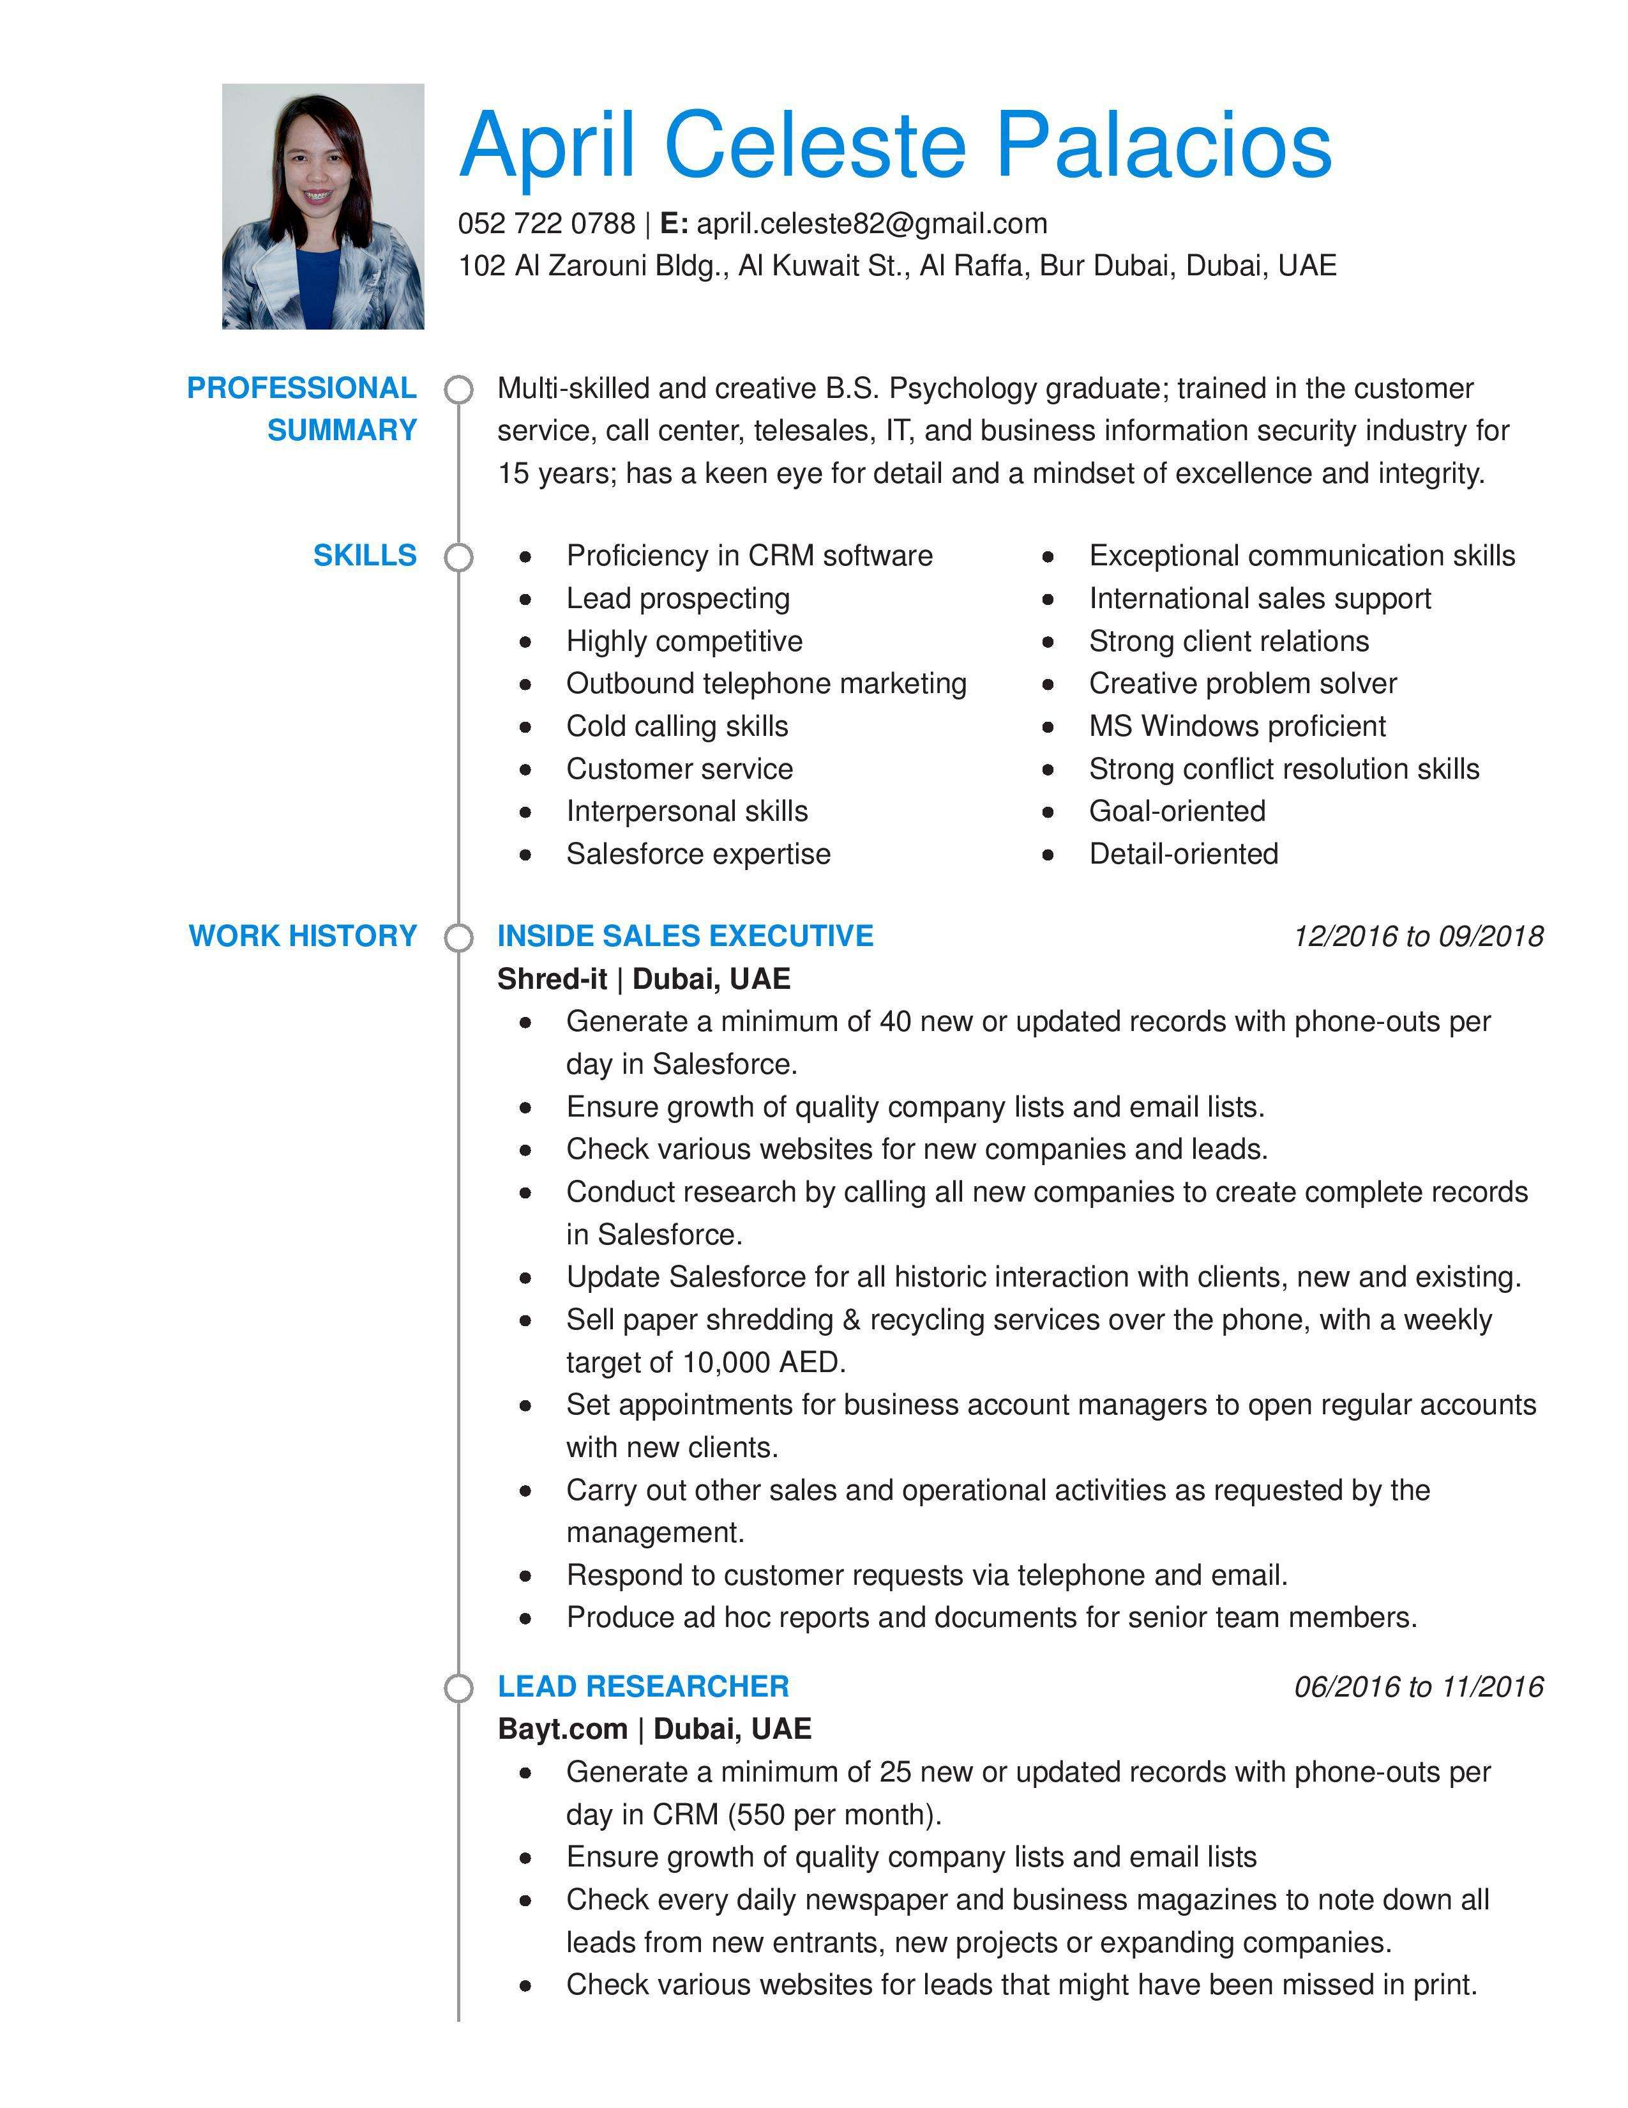

Check same area/zone "directories" to ensure capture of 100% of companies in CRM as prospects.
Conduct research by calling all new companies to create records with all mandatory fields of all companies in CRM.
Update CRM for all historic interaction with companies.

Carry out other sales and operational activities as requested by the management.

ERP TELEMARKETER AND OFFICE RECEPTIONIST 02/2014 to 04/2016

Akshay Software Technologies Limited | Dubai, UAE

Call prospective customers with the goal of arranging sales meetings with Marketing Manager and the company decision-maker; introduce the company profile and product; develop most effective call flow; submit weekly reports of leads and inquiries acquired.
Handle lead generation. Develop several business lists of potential prospects; identify key buying influencers.
Handle customer inquiry, in person or over the telephone; contributes to team effort by accomplishing related results as needed.
Maintain effective records and administration; communication and correspondence.
Coordinate office inventory by restocking supplies and placing purchase orders.
Prepare packages for shipment, pickup or courier delivery to customers. Receive and route business correspondence to correct department or staff member.
Provide clerical support to company employees, including copying, faxing and file management.
Greet incoming customers in a professional manner and provide friendly, knowledgeable assistance.

CUSTOMER SERVICE MANAGER 06/2012 to 10/2013

Push Press Labs | Iligan , Philippines

Handle customer service, web development & design, management and administrative roles.
Handle customer support through email and phone.

Respond to customer requests with friendly, knowledgeable service and support.
Manage a team of customer service reps and web developers; conduct meetings with the CEO and the team, to come up with a more effective workflow and increased customer satisfaction.
Perform basic WordPress updates; collaborate on ideas in website design; edit photos using Adobe Photoshop and LightRoom.
Manage all documented tasks for the team in online softwares (Zendesk, Asana, Google Drive, Jing, WeTransfer, etc.).
Assist in recruitment, hiring and training customer service reps and web developers; manage employee schedule and shifting.

Develop highly empathetic client relationships and earned a reputation for exceeding service standard goals.
Effective liaison between customers and internal departments. Update customer orders from start to finish in an accurate and timely manner.
Assume ownership over team productivity and manage work flow to meet or exceed quality service goals.
Train staff on operating procedures and company services.

NETWORK MARKETING PROFESSIONAL 11/2009 to 06/2012

Unlimited Network of Opportunities International Corporation | Cagayan de Oro City, Philippines

Promote and distribute organic beauty and health products, and business packages.
Recruit distributors to be part of a multi-level marketing group

Handle large groups of fellow distributors in wealth-building, leadership, and network marketing.
Plan and conduct monthly, quarterly, and yearly events for the group. Develop a comprehensive training program for new sales associates. Prepare sales presentations for clients showing the success and credibility of UNO products.
Build relationships with customers and the community to establish long-term business growth.
Train all incoming sales team members.

Organize promotional events to increase sales volume.

QUALITY ASSURANCE SPECIALIST 04/2007 to 11/2009

Synnex - Concentrix Corporation | Cagayan de Oro City, Philippines

Got promoted from Product Support Specialist to Quality Assurance Specialist in the same company after 5 months.
Educate employees on specific QA standards and confirm all standards were being maintained.
Prepare QA evaluation reports and submit to management. Support the company in maintaining a work environment focused on quality, communication, customer service, product knowledge and teamwork.
Monitor and evaluate recorded or live agent calls daily, based on communication and technical skills
Conduct individual and team coaching, providing agents with constructive feedback, both positive and negative, for each call handled to ensure conformance to quality standards.
Brainstorm on most ideal call flow for increased customer satisfaction Prepare weekly reports for QA team and the whole operations (Margin of Error report, and Grammar coaching emails)

PRODUCT SUPPORT SPECIALIST 07/2005 to 04/2007

Synnex - Concentrix Corporation | Cagayan de Oro City, Philippines

Provide voice technical support for US and UK Linksys clients on installing and fixing networking devices
Manage call flow and respond to technical support needs of customers. Provide information in response to inquiries about products or services; handle and resolve customer complaints; ensure high customer satisfaction and first call resolution
Enter all customer details and call information in CRM accessible through case numbers
Got promoted from Product Support Representative to Product Support Specialist after 17 months.
3 years of technical support experience.

PROMOTIONAL SUPPORT REPRESENTATIVE 12/2002 to 04/2005

Wyeth Nutrition | Cagayan de Oro City, Philippines

Develop & maintain strong client relationships in barangay health centers and hospitals
Present and promote infant formula products to customers

Attend company meetings and sales trainings on a regular basis

Conduct educational classes/activities for pregnant and nursing mothers

Assist in conferences for midwives, nurses, and other medical staff.

Submit weekly and monthly reports to management.

Maintain an extensive knowledge of competitors, their offerings and their presence in assigned territory.

EDUCATION |  | Bachelor of Science | Psychology | 2002

Mindanao State University - Iligan Institute of Technology, Iligan City, Philippines

Graduated cum laude

Dean's List [1998-2002]

Elected to Secretary for MSU-IIT Psychological Society in 2000

Graduated Top 1 of BS Psychology Batch 2002

