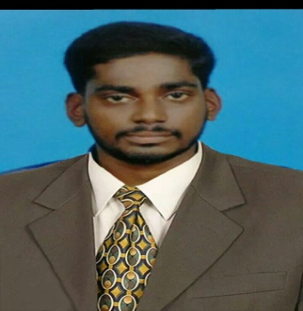SRIBAAL
Email: sribaal.383947@2freemail.com

OBJECTIVE
In pursuit of challenging position in IT/Software programing to enrich sustainable growth of organization enabling me as expertise in business functions.

EDUCATION
- Master of Technology ,Bharathidasan University from 2015-2017
- Bachelor of Technology ,Bharathidasan University from 2011 – 2015
EXECUTIVE SUMMARY
- Focused computer professional with a Masters of Technology
- Endowed with a passion for winning as evinced through demonstrated excellence in the professional experience.
- Abilities to work under tight deadlines in handling multiple priorities, with a bias for action and a genuine interest in personal and professional development.
- Ability to interpret at professional level with excellent analytical skills.

EXPERIENCE
- Worked in DOD IT Solution Company, Trichy-India as Trainer fromJuly 2017 to August 2018

JOB RESPOSIBILITIES
- Assist systeminstallation, configuration and on-goingusability of system bothhardware and software.
- Offer daily operations and system support personal.
- Verify functionality of hardware and software components.
- Troubleshoot hardware and software issues in person, remotely and via phone
- Assist employees with computer problems and answer their questions

TECHNICAL SKILLS
- Operating System : Windows & Linux
- Languages : .Net Programming &PHP.
- Databases : My SQL &MS Access
- Web Technologies : HTML
- Packages : MS-Word, Excel, Power point
- Others : Photoshop.
- Tools Worked : Xampp

PERSONAL DATA
- Nationality : Indian
- Date Of Birth : 25-05-1993
- Marital Status : Single
- Visa Status : Visit visa
- Languages Know : English, Tamil.

