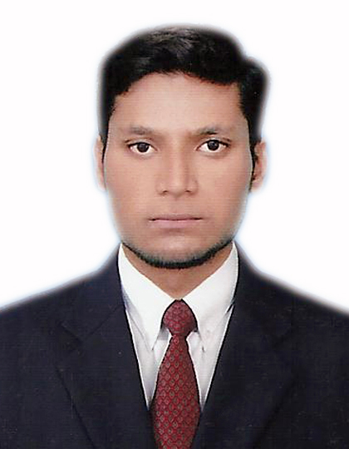Hafiz
Email: hafiz.383959@2freemail.com
Living Status: Dubai Availability: Immediately

CV for the post of Civil Engineer
Seeking a career with a suitable job according to my Qualification and ability, which will provide me the platform for become a well recognized professional. Ultimate attaining prestige and pride for the organization and myself.

Work Experience

1 years 2 month Experience As a Trainee Civil Engineer in United Builders Pakistan.
Duration: From 24/06/2015 to 23/08/2016
Position: Trainee Civil Engineer
Responsibilities:
- Setting out the works in accordance with the drawings and specification.
- Inspect and Check All contraction work.
- Observance of safety requirements.
- Resolving technical issues with employer’s representatives, suppliers, subcontractors and statutory authorities.
- To ensure Quality Control during All Phases.

(2) Work Experience

2 year Experience As a Civil Engineer in Al Muzamil Constructor Pakistan.
Duration: From 28/08/2016 to 27/08/2018

Position: Civil Engineer

Responsibilities:
- Estimating Brick, Sand, Cement, and Crush.
- To ensure the work according the drawing.
- Supervising the Site.
- Coordination between Contractor and Subcontractor.
- Making and Modify All 2D Drawing in Cad.
- To observe all work and labor individually during the work.
- Surveying with Level Instrument.
- To ensure Work Quality and safety.

Professional Qualification
- Bachelor of Technology in Civil Engineering
Attested from HEC, Ministry of Foreign Affairs & UAE Embassy
Session 2013-2015

- Three Years Diploma in Civil Engineering
Punjab Board of Technical Education, Lahore
Session 2009-2012

- Secondary School Certificate
Board of Intermediate Secondary Education, Bahawalpur
Session 2008-2009

Additional Short Diplomas

- 6 Month Diploma in Auto Cad 2D/3D

- 6 Month Diploma in Civil Surveyor

Personal Profile

- Diploma in Computer Graphics (Skill Development Council)

- Date of Birth: 03-09-1992
- Marital Status: Single
- Nationality: Pakistani
- Religion: Islam
- Languages English, Urdu, Hindi

Declaration

I hereby declared that all information furnished above is true to the best of my knowledge and belief.

