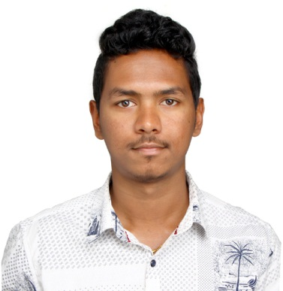
VITTO

Dubai

Email: vitto.383980@2freemail.com

Career Objective

To pursue growth of my career in a competitive and challenging work environment which will enable me to learn, grow and substantially build on my knowledge acquired during the course of my study and at the same time give me an opportunity to contribute to the growth of organization where I work.

Work Experience

- Nova Computers, Thrissur, Kerala from Nov 2015 to Dec 2017
Worked as Service Engineer
Working Knowledge in CCNA- Routing & Switch
Done Desktop Computer Assembling,Troubleshooting, OS installation, Software installation, Printer installation, Laptop repair & servicing.

- Gils lap worldThrissur, kerala from Sep 2014 to Oct 2015
Worked as Service Engineer
Done Desktop Computer Assembling,Troubleshooting, OS installation, Software installation, Printer installation, Laptop repair & servicing.

Profesional Qualifications

1.Keltron Certified Engineer in Enterprise Network Administration in 2017
2. Computer Hardware and Networking Engineering
3. Professional Diploma in IT Infrastructure Management
4.Diploma in Computer Hardware Maintenance & Networking from Sree Rama Govt. Polytechnic College Triprayar in 2013

Education Qualification

1. Completed Bachelor of Commerce from MaduraiKamaraj University in 2017
2. 12th std. from Board of Higher Secondary Examination passed in Year 2014
3. 10th std. passed in Year 2010

Computer Skills

1.Photoshop cs6
2. MS Office

Personality Traits

Hobbies Listening music, Traveling, Playing (cricket)
Qualities Disciplined, Honest & Smart working.

Strengths

1. Analytical mind to identify problems and implement effective solution.
2. Flexible by nature.
3. Positive Attitude.
4. Hard working & Self Confident.
5. Willing to work among team

Personal Profile

Name : VITTO
Date of Birth : February 05th 1993
Nationality : Indian
Language Known : Malayalam, English& Tamil

Declaration

I hereby declare that the above-mentioned information is correct up to my knowledge and I bear the responsibility for the correctness of the above-mentioned particulars.

