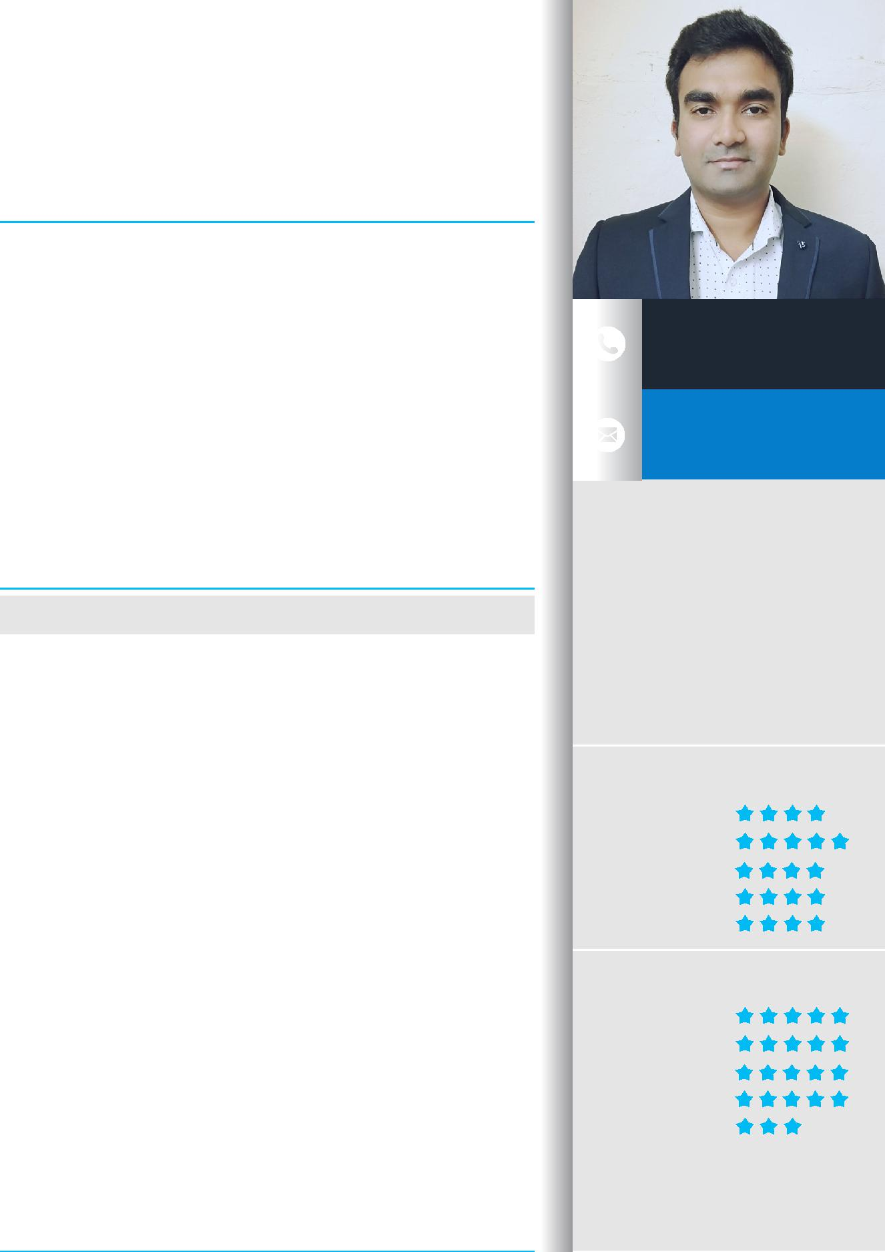
FASEEH

I am an MBA Professional with an optimistic attitude towards achieving my objectives with diversi ed experience. Pro cient in FMCG HORECA Sales, Business Development, Contracts & Negotiations. Possess 12 years of professional experience and still learning. Focused on building successful business partnerships with consistent performance and unwavering dedication to excellence.

 | EXPERTISE
FMCG Width and Depth Distribution | Product Market & Segmentation
RED (Right Execution Daily) | Team Building & Leadership
Strategic Planner
 | EDUCATION

Manipal University - Dubai Campus

MBA (Marketing)

2004 - 2006

S.V. University
BACHELOR OF COMPUTER APPLICATIONS

2000 - 2003

WORK EXPERIENCE

Bridge - Spoonfed Delivery Services LLC
ACCOUNT SALES MANAGER, DUBAI

Since MAY 2018

- Registering restaurants as Merchants all over Dubai

- Educating the merchants with a maths to prove how competitive Bridge is to them over in-house riders
- Designing an e ective and fuel e cient route plan for the company

Aujan Coca Cola
SALES DEVELOPER - HORECA (OOH), DUBAI

NOV 2016 - APRIL 2018

- Implementing and maintaining RED at all stores

- Sourcing new and convincing existing vendors to take company coolers, to increase sales by min 40%
- Follow the Planogram and look for PICOS always

Nohil - Unilever
AREA SALES MANAGER, INDIA

OCT 2010 - OCT 2016

- 100% width and depth distribution in the allotted geographical area

- Visit establishments to evaluate needs/ to promote products/ service sales

- Verify that materials lists are accurate and that delivery schedules meet project deadline

MD Real Estate LLC
ASST. MANAGER - SALES & LEASING, DUBAI

JUNE 2006 - SEP 2010

- Market Research often to keep updated about the prices and happenings

- Segregate the inventory based on geographical area assigned to the Sales personnel
- Maintain database of available and upcoming properties

Faseeh.383986@2freemail.com

PERSONAL

DOB | : | APRIL 28, 1982
RELATIONSHIP | : | MARRIED
NATIONALITY | : | INDIAN
DRIVING LICENSE | : | UAE, INDIA

SKILLS

TEAM BUILDING

LEADERSHIP

KEY ACCOUNT MGMT

BUSINESS STRATEGY

ANALYSIS & REPORTING

LANGUAGES

ENGLISH

URDU

HINDI

TELUGU

ARABIC

