Fathima
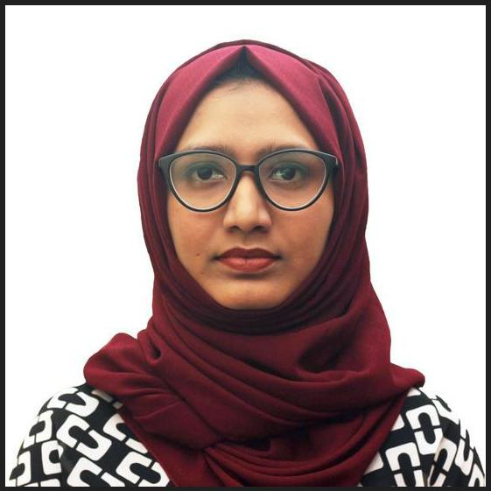

Seeking HR Opportunities in UAE

Fathima.384004@2freemail.com

Summary Top Skills

MBA Graduate with dual specialization in Human Resource Management and Marketing seeking HR jobs in UAE. Holds 1 year experience as Business Development Executive in an IT company. Seeking a challenging position in the industry to start my HR career, where i can apply my skills and ability, to utilize my interpersonal skills in order to maintain a motivated, productive, and goal oriented organization.

Work experience

Business Development Executive | 2017 - 2018
Vinam Solutions Private Ltd, Calicut, Kerala, India

Managing and building large email campaigns.

Gaining a clear understanding of customer's businesses and requirements.

Handling client queries with key focus on customer satisfaction.

Performing daily email marketing activities.

Liaising between customers and their existing and potential clients.

Acquiring new business through email marketing and cold calling.

Updating and maintaining the CRM system,

Education

Master of Business Administration, MBA | 2015 - 2017

Farook Institute of Management Studies FIMS

Specialized in Human Resource Management and Marketing

Self Motivated

Decision Making

Leadership

Team Management

Emotional Intelligence

Customer Relationship Management

Client Handling

Extra Curricular

Integral member of the Save Water Campaign to raise awareness to preserve water.
Core committee member and creative department head of the intercollegiate National Level Management Meet ( FIMS CANVAS 2k16 -17) conducted by Farook Institute of Management Studies.
Lead a team as a house captain during school days.
Volunteered for events for social causes like Pain & Palliative Care, Run Kerala Run etc.
Won individual level championships in co-curricular activities.
Won several prizes for Mehendi / Henna designing competitions.

Bachelor of Business Administration |  | 2012 - 2015
 |  |  |  | Personal Hobbies
University of Calicut
 |  |  |  | Creative Arts
Board of Higher Secondary Examinations, Kerala |  | 2010 - 2012
 |  |  |  | Henna Artist
Auxilium Nava Jyoti School |  |  |  | Painting & Drawing
 |  |  |  | Languages known
Projects Done

PG Major: Case study on The Impact of Customer Relationship Management on Customer loyalty at Eram Motors, Calicut.

PG Minor: Case study on Quality of Work Life of employees at M/s Smartak Footcare Pvt.

Ltd, Calicut.

Degree: A study to understand the Effectiveness of Training and Development with special reference to M/s Fortune Elastomers Pvt. Ltd, Calicut.

English (Read, Write, Speak)

Malayalam (Read, Write, Speak)

Hindi (Read, Write, Speak)

Arabic (Read and Write)

