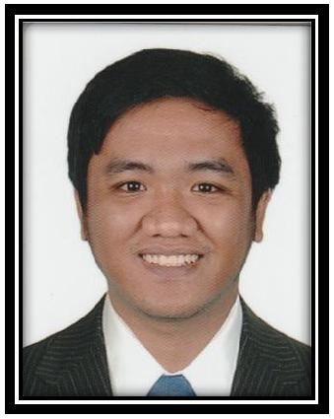
John

Graphic Designer / Videographer

Email | : john.384006@2freemail.com

I. CAREER OBJECTIVE

To obtain a position in the field of digital arts when I can enhance and contribute my skills in Photography, Videographer, Photoshop, Premiere Pro, InDesign, to help maintain the success of the company.

- ACADEMIC INFORMATION A. Education

2012 – 2018 FEU Institute of Technology

P. Paredes St., Sampaloc, Manila, Philippines

BACHELOR OF SCIENCE IN INFORMATION

TECHNOLOGY WITH SPECIALIZATION IN DIGITAL ARTS

B. Projects Accomplished

  - Berong Bumbero: A 3D Film to Promote Existing Fire Prevention Program of Bureau of Fire Protection Manila

  - A photography and photo manipulation for photography project

  - 3D Models complete with texture for requirements in class

  - Short film creations with visual effects and editing for video editing class

  - A fully functional website created for promotion of client and thesis Project

C. Awards / Certifications Received

  - Autodesk Certified Professional: Maya, February 2014

- SOFTWARE PROFICIENCY

- Adobe

  - Photoshop o Illustrator o InDesign

o Premiere Pro o After Effects

- Autodesk Maya

- Microsoft Office (Word, PowerPoint)

IV. WORK EXPERIENCE

- StolenShots Studios Videographer
October 2016 – September 2018

Projects Accomplished:

  - A after movie of Paskuhan 2017

  - A interview of best employees of B Braun

  - A advertising Video of Splash Island

  - A father’s day special of Selecta

  - A after movie of Hydro Manila 2018

  - A series of Fangirl Diaries: Wannable’s Way

  - A short film about Agriculture

  - A documentary of Aeta being aspiring Singer

- StolenShots Studios

Videographer / Photographer

December 2017 – March 2018

- Unilab Foundation

Intern Graphic Designer

August – October 2017

I hereby attest that all information contained herein is true and correct.

