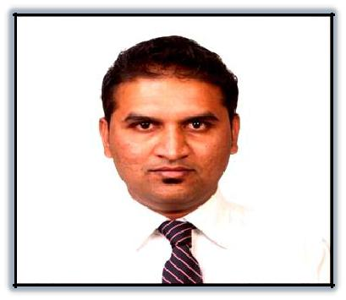
Anish

Email: anish.384008@2freemail.com

Dubai, UAE

Career Objective:

A self-motivated, result oriented professional with hands on experience in Human Resources, Training & development, Customer Service, Operations and Retails sector.

Professional Summary:

7+ years of experience as HR Executive and customer service executive with a variety of field’s, job description and evaluation, organisation structuring, training, employee engagement, performance management and development, reward & recognition, policy formulation and implementation, talent acquisition & retention and vendor management.

Work Experience:

HR Executive at Rang Technologies, Vadodara, Gujarat India (July 2017 – Jan 2018)

- Recruiting and staffing logistics.
- Job Description and Evaluation.

- On boarding and Induction.
- Employment and compliance to regulatory concerns and reporting.

- Background checks and Reference checks
- Employee orientation, development and training.

- Policy development and documentation.
- Employee Engagement.

- Company-wide committee facilitation.
- Company employee communication.
- Compensation and benefits administration.

- Employee safety, welfare, wellness and health.
- Employee services and counselling

- Exit formalities.

- BD manager’s expenses validate and provide approval to payroll team for reimbursement.

- Helping Immigration team to maintain H1B and OPT/CPT related documents and keep employees updated for same.

US HR Executive at Collabera Inc., Vadodara, Gujarat India (June 2015-July 2017)

- Performing on boarding processes for new hires in accordance with the company and client policies and US State and Federal Government guidelines.

- Background checks and Reference checks as per client compliances.

- Communicating to the prospective employees the company’s framework and policies and those of US Department of Labour and other parties that may be involved.

- Analysis and verification of all the documents received from prospective employees and identifying deficiencies if any.

- Creating a positive employee experience.

- Coordinating with external parties- Vendors, Business Partners etc. to complete statutory requirements in line with company policies.

- Coordinating with the internal teams to make sure that tasks are brought to logical conclusion in a defined time frame.

- Contribute to Client Audits, Reports, Data compilation and analytical presentation.

- Resolving Billing problems including P.O. extensions, invoice rejections and P.O. budget issues.
- Following up with the client/sales teams for P.O.

- Handling miscellaneous requests from sub-tiers, clients and consultants.

Customer Service Assistant at ASDA Superstore, London United Kingdom
(September 2009- April 2014)

- Analyze and resolve operations and marketing related issues.
- Updating line employees on upcoming business processes from time to time

- Providing reports for analysis of business performance and growth
- Manage and monitor service desk performance

- Monitoring and ensuring documentation is accurate and complete
- Assisting customers with their queries

- Investigate and Resolve Customer complaints

- Documented success in promoting the company positively during regular working hours and at special events

- Demonstrated expertise in assisting customers with product selection and providing them with support throughout the checkout process
- Familiar with handling stocking duties and managing supplies inventories

- Adept at communicating positively with customers to ensure an enjoyable shopping experience

- Deliver excellent communication to department teams by updating the huddle file daily and delivering huddle information throughout every shift of the day.

- Encourage and motivate colleagues to be the best, providing excellent customer service.

- Ensure colleagues are available to serve the customer by ensuring overtime is covered, holiday planning is competed and Q-busters available. Follow the company absence process to minimize department absence.

Academic Qualifications:

May 2007- Bachelors of Business Administration (BBA) from Saurashtra University, Rajkot, Gujarat, India

Computer Skills:

- Operating Systems: Microsoft Windows 9x/Me/2000/XP
- Web Designing Software: Photoshop, Flash 4, FrontPage, HTML

- Applications: MS Office (Word, Excel, PowerPoint, Outlook, Access)

Personal Details:
Date of Birth | : | 30th May 1985
Nationality | : | Indian
Marital Status : |  | Married
Languages | : | English, Hindi, Gujarati (Read, Write and Speak)
Visa Status | : | Visit Visa

References Available on Request

