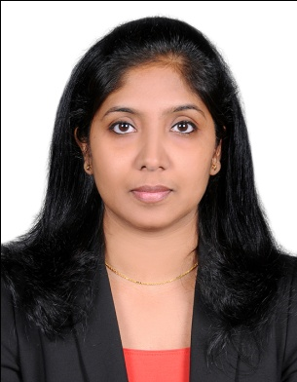
Christy

Christy.384022@2freemail.com

Professional Summary
Dedicated to delivering quality eye care to patients and advocate for educating patients about their eye health ; with excellent time management skills and organizational skills. Professional experience of twelve years in Optometry practice.
Skill Highlights
- Refraction-objective and subjective
- Contact lens fitting and assessment
- Tonometry
- Perimetry
- OCT
- A-Scan Biometry
- Pachymetry
- LASIK work up

Affiliations
Dubai Health Authority License No.DHA-P-0078303
Indian Optometric Association (IOA) Lifetime Member
Optometry Council Of India Member

Professional Experience
International Modern Hospital - Dubai July 2015 to present
Optometrist
- Responsibilities include:
  - Conducting objective and subjective refraction
- Conducting Perimetry,Corneal Topography,OCT Scanning
Edimannickal Opticals & Eye Clinic - India August 2011 to December 2014
Senior Optometrist
- Responsibilities include:
  - Eye testing, prescribing spectacles,contact lenses,helping sales personnel if needed,and answering queries and providing suggestions related to eye care to the customers.
Vasan Eye Care Hospital - India May 2007 to August 2011
Senior Optometrist
- Responsibilities include:
  - Conduct objective & subjective refractions and prescribing spectacles in out-patient department
  - Eye assessment,Contact lens trial, fit assessment, and prescribe appropriate Contact lens for the patients
  - Conduct A-Scan biometry, Perimetry, OCT scanning, Tonometry, and Pachymetry
  - Pre and Post Lasik work-up like Orbscan, Aberrometry and assisting Lasik
surgeon in Lasik OT

Medea Lasik & Laser Centre - India October 2005 to April 2007
Optometrist
- Responsibilities include:
  - Conduct objective & subjective refractions in Lasik Clinic
  - Pre and Post Lasik work-up like Orbscan, Aberrometry and assisting Lasik surgeon in Lasik OT
St. Joseph's Eye Hospital & Laser Centre - India May 2005 to Sep 2005
Optometrist
- Responsibilities include:
  - Conduct objective & subjective refractions and prescribing spectacles in out-patient department
  - Eye assessment,Contact lens trial, fit assessment, and prescribe appropriate Contact lens for thepatients
  - Conduct A-Scan biometry, Perimetry, Tonometry, and Pachymetry
Education and Training
- School Of Medical Education, Mahatma Gandhi University - 2004
  - Bachelor of Science: Optometry - Kottayam, Kerala, India

- Assumption College, Mahatma Gandhi University - 2000
  - Pre University: Science - Kottayam, Kerala, India

- Kristu Jyoti English High School - 1998
  - Secondary School - Kottayam, Kerala, India
Certifications
- Mastermind and Mastermind Plus programmes in 2008 and 2009 respectively conducted by Bausch and Lomb University in association with International Association of Contact Lens Educators at Vasan Eye Care Hospital, Cochin, Kerala, India

- Contact lens education programmes on contact lens basics and management of astigmatism with soft toric contact lenses conducted by the Vision Care Institute of Johnson & Johnson in2009 at Delhi, India

Project Completed
- Comparative Study of Visual Outcome after Ecce and Phacoemulsification(Done in 2003)
Personal Information
Age & Date of Birth: 35, 02-04-1983
Nationality: Indian
Marital Status: Married
Languages Known: English, Hindi and Malayalam
Visa Status: Employment Visa

