VISAKAN, B.E.Civil,
email id:-visakan.384042@2freemail.com

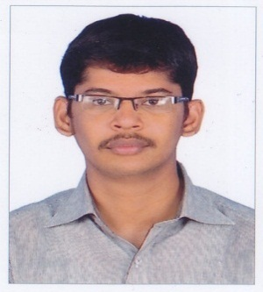

Career Objectives:-
I am a civil graduate , having more than 4 years experience in relevant field.
Experience in project execution as a site engineer &project monitoringfrom field and also from office. Experience in design co-ordination through design team, in addition to thathaving experience in PHE design.

Educational Qualifications:-
B.E.Civil - Kamaraj College Of Engineering & Technology,Virudhunagar.-2014- 7.91 CGPA
HSSC - S.H.N.V.Mat.Hr.Sec.School,Sivakasi. -2010 - 80%
SSLC - N.P.S.S.R.K.Rotary Mat.Hr.Sec.School,Sivakasi - 2008 - 81%

Experience:
Organization : Sivalayam Enterprises, Tiruvanamalai .
Position :- Site Engineer , FromDecember’17 To still date
Role:-Executionof site
Sivam Gardens – Includes 20 No’s of individual villas & 52 No’s of Flats(2 Blocks).

Organization : Casa Grand Pvt Ltd , Chennai .
Position :- Junior Executive Customization & Coordination, From February ’15 to November’17 -3years
Design Coordination for following projects
1.CG Cherrypick - Chennai
2. CG Aristo - Chennai
3.CG Ritz - Chennai
4.CG Vivant- Chennai
5.CG Masseys - Chennai
6.CG Arena – Chennai
Experience:-
    - Preparation of working drawing,
    - Preparation of Project FLOW CHART.& monitoring execution as per schedules.
    - Conduct the periodical meeting with architect & structural engineer ,project incharge for finalisethe layout as per site condition.
    - Preparation of Handing over documents& CMDA approval layouts.
    - Preparation of brochure drawings ,Area statement for sales & Brochure details.
7.CG Luxus -Bangalore
    - Monitoring the site execution as per designed layout .
    - Plumbing designer for the project as per site condition.

Quantity Surveyor
    - Quantity freezing & Budget preparation.
    - Plumbing material BOQ preparation.
Customization Engineer:
    - Preparation of modification drawings of individual flats as per client requirement & monitoring of execute the same in site. Preparation of costing sheet for the revised layout .
Plumbing Designer:
    - Preparation of plumbing layout for more than 1,25,000 sft.(more than 5 projects)
    - Preparation of both Internal & External plumbing layout .
    - Monitoring plumbing execution in site as per layout.

Organization : Green Interiors, Karur
Position :- Site Engineer, From July’14 to January’15- 6 months
Experience :-Quantity assessment & Quality check of material & workmanship.
Software Skills:-
- Revit Arch.
- STADD .Pro.
- Google sketchup
- Auto Cadd
PERSONAL DETAILS:-

Date of birth : 5 MARCH 1993
Gender : Male
Marital status : Single
Nationality : Indian
Language known : Tamil , English ,Telugu (speak)

