USMAN

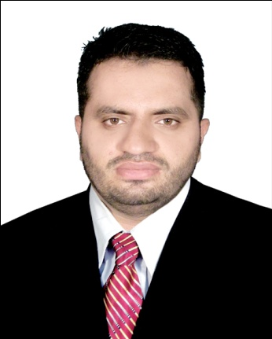  PERSONAL DETAILS:  Father’s Name :  Date of Birth :  31/07/1995  Gender :  Male  Marital Status :  Single  Domicile :  Multan (Punjab) Pakistan  EMAIL:  Usman.384251@2freemail.com  INTERESTS:  - Business & Economic Article in Newspapers  - Study of KSE  - Study of Foreign Exchange  - Internet Searching  REFERENCE:  Will be Furnished on demand | CAREER OBJECTIVE:  Seeking a career with a career oriented organization; that can provide me the platform for becoming a well-recognized professional and ultimately attaining prestige and pride for the organization and for myself as well.  ACADEMICS  - B.B.A. (Hons) (2013-2017)  1st division  NFC-IET Multan  - HSSC (FSC) (2011-2013)  2nd division  RISE COLLEGE OF MULTAN  Board of Intermediate & Secondary Education Multan  - SSC (2009-2011)  1st division  NOUKHEZ PUBLIC HIGH SCHOOL MULTAN  Board of Intermediate & Secondary Education Multan  SUBJECT SKILLS  - Business Communication  - Cost Accounting  - Financial Management  - Organizational Behaviour  - Business Statistics  - Human Resource Management  PROJECTS & REPORTS  - Research Report on PTCL  - Research Report on Agro Mart  EXPERIENCE  - Haier (Outlet) Part Time Job  Designation: Sales & Marketing  Duration: 02 Years & Six Months  - Changhung Ruba Electronics Company  Designation: Sales Officer  Duration: 01 Year  Role & Responsibilities in Changhomg Ruba:  - Make strong relationship with company Dealer  - Enhance Company sales(Order Taking)  - Insure Payment from Dealer before Due Date  key skills:  - Target Oriented  - Self Motivated  - Capacity to bear Pressure.  - Good decision making skills  Language skills:  - Urdu (Read, Write, Speak) Excellent  - English (Read, Write, Speak) Excellent  Computer Skills:  - Working in accounting software based in MS Access.  - MS Word, Excel, PowerPoint  - Internet Web Surfing & Mailing  - Installation & Operating window 2000, XP

