Visa Status: Tourist
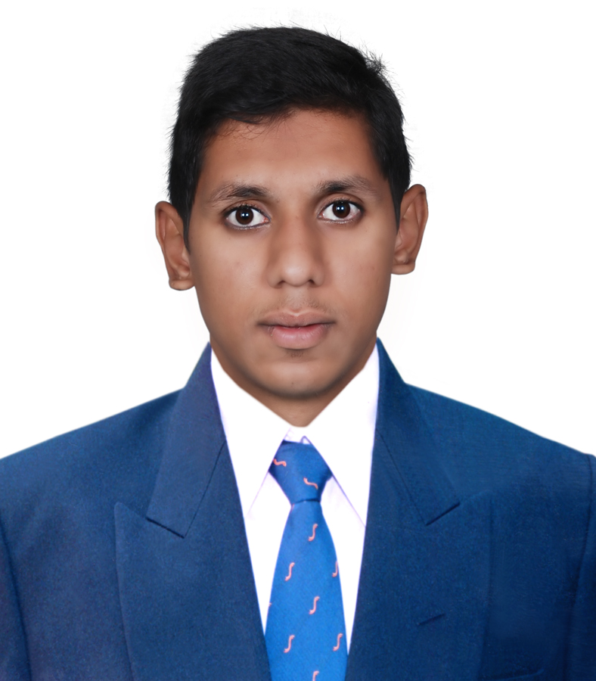
AbuDhabi,UAE

Mohammad.384261@2freemail.com

MOHAMMAD

PROFESSIONAL SUMMARY
Versatile and disciplined Mechanical & Plumbing Engineering professional with 3 years of progressively responsible experience, committed to the achievement and maintenance of quality. Considers multiple alternatives and quickly identifies the source of problems; organizes and manages time effectively; works efficiently as an individual or within groups.

EDUCATION Bachelor of Technology in Mechanical Engineering from JNTUH, India

EXPERIENCEMECHANICAL ENGINEER (HVAC, FIRE FIGHTING, PLUMBING)

COMPASS PROJECTS &CONSTRUCTION,DOHA, QATAR
August 2015– July 2017

Project : Shoumoukh Twin Towers, Doha, Qatar
Client : Johnson Controls Consultant : KEO Consultants
Duration: 2 Years

- Selection & Installation of Chillers, AHU’S, FCU’S, Exhaust Fan, Blower and other Accessories.
- Calculation of static pressure of Blowers, compressors & Pumps and their selection.
- Air Conditioning Cooling Load calculations, Heat Load calculations following ASHRAE codes.
- Reading and guiding for Line diagrams of the Refrigeration.
- Duct system design, supervision, duct fabrication and installation as per ASHRAE.
- Ensure that all HVAC site activities are conducted under controlled conditions as per shop drawings.
- Ensure safe work environments, control the use of material and avoid damages and waste.
- Co-ordination with architectural and structural & all MEP work.
- Reviewing submittals before submitted to Company and Contractors
- Making meeting with supplier and consultant and Aramco engineering dept. to clarification of materials as per the project specification or compliance statement.
- Visiting the factory with consultant for material inspection before deliver to site,
- Ensure that all the Mechanical site works are being carried as per the approved drawings and scope of work.
- Co-ordinate with Civil and Electrical teams to ensure that there shall not be any mismatch during installation works. Prepare daily reports/weekly reports for the progress of work.
- Ensured that all site operations were carried out in safe productive manner. Prepared project timelines and made projection adjustments as necessary.Worked with budget department to determine estimated operations expenses.Prepared charts diagrams graphs and presentations to illustrate logistics issues.

SADARA CHEMICAL COMPANY - CONSTRUCTION,RIYADH (KSA)
July2017–August2018

Project : Hilton Hotel and Residence– Riyadh
Client : Al Yamama COMPANY
Project Management :NESMA Partners
Consultant : Alrabiah consultants and Engineers

- Assist in the data collection and/or field verification.
- Research NFPA Standards and Building, Plumbing, and Gas Codes.
- Assist in Assist in the development of design approaches and concepts on assigned.
- the selection of equipment to fit the project design.
- Produce detailed plumbing and fire protection layouts in AutoCAD and Revit, based on applicable codes and standards.
- Produce plumbing fixture schedules and riser diagrams.
- Produce project based plumbing and fire protection specifications.
- Ensure that all drawings are prepared with accuracy, neatness, and prior to project deadline.

TECHNICAL EDUCATION:
- Certified inAutoCAD fromAutodesk.
- HAP, E20 form (Heat load Calculation).
- Cold storage, Compressors, Chillers.
- DUCT, Pipe sizer
- VRF/VRV Systems

ACADEMICACHIEVEMENTS

- A Member of SAE (Society of Automotive Engineers).
- Consistently Good in my Academic Career

COMPUTER SKILLS
•GoodCommandover ComputerApplications inMS-OFFICE.
•C,WindowsXP/Vista/7/8

STRENGTHSProfessionalSkills:
- Inter-Personal Skills, PresentationSkills.
- AbilityforConvincing,Influencing&Negotiating.
- Buildingrelationships
- Creative thinking

BehavioralQualities:
- Abilityto adapt to aworkingenvironment.
- Openness to improvement,development &change.
- Energetic and self-motivated.
- Desire toGrow,Develop& Achieve.

INTERESTS•To keep update myself byreadingnewspapers, magazines &portals.

PERSONAL INFO Date of Birth 27thDecember, 1993
Nationality Indian
Gender Male
Languages Known English, Hindi,Urdu,Arabic (partial)
MaritalStatus Single
Visa Status Tourist

DECLARATIONI hereby declare that the above information is correct to the best ofmy knowledge.

