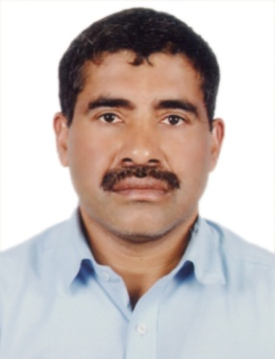

ISMAIL

Email: ismail.384262@2freemail.com

APPLIED FOR driver

PROFILE
A Suitable position with an organization where I can utilize the best of my skills and abilities that fit to my education, skills and experience encouraged and permitted to be an active participant to give vital contribution for development of the company.

Skills:-
- Well knowledge about Dubai –UAE Road and location.
- Very Energetic result oriented and organized
- Efficient and well behaved person
- Extremely hardworking self-motivated and able to work independently in a team environment under supervision
- Keep excellent inter personal relations with colleagues and ready to help them

Personal INFORMATION
Date of Birth : 10.08.1973
Marital Status : Married
Nationality : Indian
Language Known : Hindi, English, Arabic, Parsi, Tamil, Malayalam, Kannada.
Visa Status : Employment Visa

educational qualification
- High School

work experience total 16 years
- Worked as a Driver BIN MOOSA & DALY LTD LLC in Dubai Br (UAE)
9 years (2008 – 2018)
- Worked as Driver National Taxi in Dubai 5 years (2000 – 2005)
- Worked as Messenger in Qasim Travel and Tourism in Dubai (2005-2007)
DUTIES RESPONSIBILITIES
- Leading to team work and arrange the manpower
- Installing electrical panels, conduit, and cabling.
- Install repair and maintain power distribution systems, panels, subpanels.
- Study Blueprints and layout work for helpers.
- Request Materials for future work.
- Install and wire switchboards and transformers.
- Troubleshooting and repairing in a timely minor.
- HV cable pulling, joint, test and termination
- Electrical equipment installation (junction box, lighting, electrical switchboard, pump.

LICENSE DETAILS
Date of issue : 08.03.1998
Date of Expiry : 07.03.2023
Category : Light Vehicle./Heavy Bus, Mini Bus
Place of Issue : Dubai.

passport details
Issue Date : 17.04.2013
Expiry Date : 16.04.2023
Place of Issue : Dubai.

declaration

Here I am kindly declared that the above mentioned details all are true in the best of my knowledge and believe.

