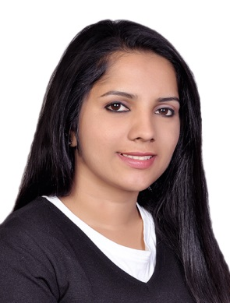
Aswathy
(BDS)

Email– aswathy.384564@2freemail.com

Personal Summary
I am a professional Dental surgeon with more than 6 years of clinical experience. Aim to secure a responsible position in the field of insurance where able to utilize my knowledge and technical skills by maintaining a positive environment in the work place. Possess the ability to create and present an excellent image of the organization and its service to customers.

PersonalDetails
Name Aswathy
Sex Female
DOB 25-05-1988
Marital Status Married
Educational Status BDS
College Calicut University
Languages known English, Hindi, Malayalam, Tamil
Visa status Resident visa

Work Experience

Worked as Dental Surgeon at Smile Dental Care, Pathanamthitta from 02/12/2013 to 08/12/2017
Worked as Dental Surgeon at Smile Orthodontic Centre & Dental Clinic, Calicut, Kerala from 11/12/2012 to 31/10/2013.
One year internship completed on 07/11/2012 as Dental Surgeon at KMCT Dental College,Calicut
Key skillsand Competencies
Well-presented and articulate.
Understanding of medical terminology in relation to diagnosis and procedures.
keeping up to date with the latest developments in dentistry.
Good knowledge of all basic computer software’s.
Excellent listening, communication and interpersonal skills.
Able to concentrate for long periods and attention to detail.
Independent, self-motivated, able to take responsibilities and work well .

AcademicProficiency

- Completed Bachelor of Dentistry (BDS) in 2011 from Calicut University, KMCT Dental College, Calicut.Percentage of marks obtained - 70 % marks.
- Completed Higher Secondary Education at GOVT HSS Thottakonam. Percentage of marks obtained -85.3 %marks.
- Completed 10th at NSS GHS, Pandalam.Percentage of marks obtained -88.5 %marks.
- Doing medical coding training in skyline training centre Dubai .

ProfessionalLicenses
Kerala Dental Council
Hold a valid DHA eligibility

Declaration

I do hereby declare that the above said particulars are true to the best of my knowledge.

