SRINIVAS

ARCHITECT

Profile

A highly motivated individual interested in the position of Architect; bringing exceptional ability to employ creativity in designing processes, expertise in employing the right methods in bringing construction projects to final completion in a time efficient manner.

Experience

Vaishnavi Estates PVT LTD & Shiva's Architect's , Hyderabad | 09.2016-04.2017 - 8 MONTHS
Professional Practice,Hyderabad

WORKS

*Triumph Villa plans and municipal drawings.

*Facade design for commercial and residential buildings.

*Conceptual design for Telangana contractors cultural club.

Team Blueprint, Hyderabad | 06.2017-05.2018 - 1YEAR
Jr. Architect ,Hyderabad

WORKS

*Commercial and Residential Presentation plans.

*Working Drawings of Apartment.

*Villa plans.

*Electrical Drawing at 3BHK.

*Interiors of 1BHK

Education

5YEARS VAISHNAVI SCHOOL OF

09.2012-08.2017 -ARCHITECTURE AND PLANNING

B. Arch , Hyderabad, affiliated to

JNAFAU

Personal Information

BUR DUBAI

INDIA
[NATIONALITY]MALE

Srinivas.384602@2freemail.com
Date of Birth: 07-09-1994

VISIT VISA
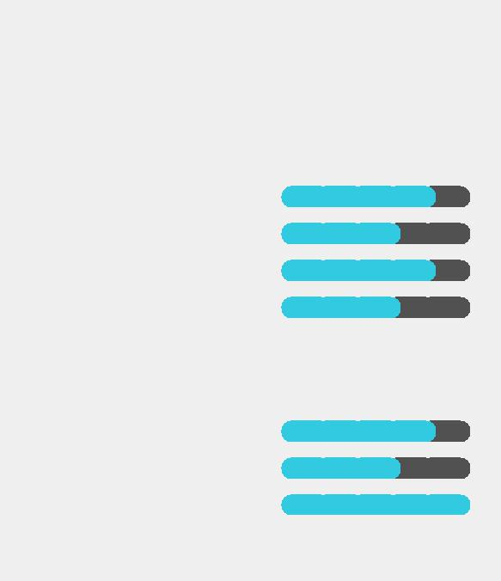

SKILLS

SOFTWARE SKILLS

AUTO CAD

REVIT

SKETCH UP

MS OFFICE

LANGUAGE

ENGLISH

HINDI

TELUGU

Personality

Positive attitude
Stress Tolerance
Critical Thinking
Interests

Swimming Soccer Meditation Cooking
Photography

ABOUT ME

Good Communication Skills- Written & Oral skills Excellent Conceptual and Analytical Skills
Effective Interpersonal Skills

CERTIFICATION

*Represented as a team leader in Marketing. [56th Annual National Architecture Student Association Convention. [Hyderabad] 2014

*Attended the Exposure Programme on Laurie Baker Philosophy in Architecture and Building Technology. [Thiruvananthapuram] 2014

*Presented about Building Information Modelling [BIM] software at The Integrated Design Approach for Better Buildings. [Hyderabad] 2015

“I can not do everything, but I can do something. I must not fail to do the something that I can do.”

HELEN KELLER

Declaration

I hereby declare that all the information provided in this profile is correct.

