CURRICULUM VITE
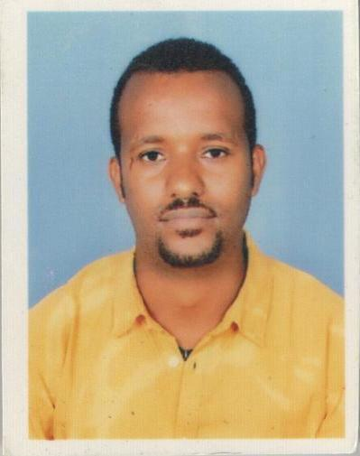

Melaku

Email: melaku.384624@2freemail.com

U.A.E

Personal information

Name

Gender

Marital status

Nationality

Melaku Tesfaye

Male

Single

Ethiopian

Education Back Ground

- BA Degree in Accounting/2014-2017/

- Diploma junior accountant/2006-2009/

- Peachtree Accounting Certificate/2012/

- Diploma In Application Software Training /2011/

Language

- English :- Speaking, Reading, Writing and Understanding very well

- Amharic:- Speaking, Reading, Writing and Understanding very well

Work experience

- For two (2) years working as Riske management officer in Dire Micro Finance Institute Harare Branch./Ethiopia/

- For one(1) years and seven(7) month working as accountant private organization employ social security agent./Ethiopia/

- For two (2) year working as accountant in Public servant social security agent/Ethiopia/

Other Ability

- Computer Application (IT)

- Driving Car (Driver)

Dutie and responsibility

- Prepare, examine, and analyze accounting records, financial statements, and other financial reports to assess accuracy, completeness, and conformance to reporting and procedural standards.
- Compute​ taxes owed and prepare tax returns, ensuring compliance with payment, reporting and other tax requirements.
- Analyze​ business operations, trends, costs, revenues, financial commitments, and obligations, to project future revenues and expenses​​or to provide advice.​
- Report​ to management regarding the finances of establishment.

- Establish tables of accounts, and assign entries to proper accounts.

- Develop,​ maintain, and analyze budgets, preparing periodic reports that compare budgeted costs to actual costs.
- Develop,​ implement, modify, and document recordkeeping and accounting systems, making use of current computer technology.
- Prepare​ forms and manuals for accounting and bookkeeping personnel, and direct their work activities.
- Survey​ operations to ascertain accounting needs and to recommend, develop, and maintain solutions to business and financial problems.
- Work​ as Internal Revenue Service agents.
- Advise management about issues such as resource utilization, tax strategies, and the assumptions underlying budget forecasts.
- Provide​ internal and external auditing services for businesses and individuals.
- Advise​ clients in areas such as compensation, employee health care benefits, the design of accounting and data processing systems, and long-range tax and estate plans.
- Investigate​ bankruptcies and other complex financial transactions and prepare reports summarizing the findings.
- Represent​ clients before taxing authorities and provide support during litigation involving financial issues.
- Appraise,​ evaluate, and inventory real property and equipment, recording information such as the property's description, value, and location.
- Maintain​ and examine the records of government agencies.
- Serve​ as bankruptcy trustees and business valuators.

Declaration

I hereby certify that the above mentioned particulars are accurate to the best of my knowledge

