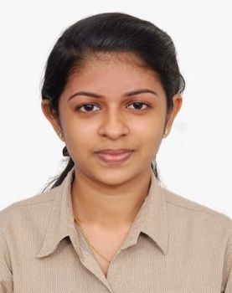
METTILDA

Email: mettilda.384700@2freemail.com

CAREER OBJECTIVE:

To be part of an organization where I can utilize and develop my creativity and technical skills effectively and thereby contribute to the betterment of the organization and of the society.

BRIEF OVERVIEW
- Two year experience in HR and IT Training division.
- Knowledge in software packages like Microsoft office word, Excel and PowerPoint.
- Ability to handle multiple priorities with a genuine interest in professional and personal development.
- A self-motivated team leader with strong analytical, interpersonal and communication skills.

WORK EXPERIENCE:

- Company name : Right Group, Ernakulum
One of the leading IT Development and Training Companies in Kerala, India.

- Manager – Right Group ( 01st January 2018 to 01st September 2018 )

  - Worked with company CEO and Director to strategize and plan company’s Operational and Business Development activities.
  - Implementing and monitoring all major operational changes.
  - Implementing and monitoring all promotional and development activities of the company.
  - Recruitment and Selection of all personnel for various divisions of the company.
  - Attendance and Leave Management
  - Coordinated all Training and Induction of all employees on company polices (including appropriate dress and social media permission etc.)
  - Monitor employee progress and stay abreast on company work climate and culture, ensuring it stays positive and productive.
  - Regularly meet with employee for progress review and assessments discussing any problems or grievances they may have.
  - Initiate and implement any necessary changes to help worker productivity (better assessment processes, incentive programs etc.)

- Academic Counselor – Right Soft Options ( 24th August 2016 to 01st January 2018)

  - Counseling the students and converting into admissions.
  - Take admission, fill the admission form, collect payments, issue receipts for payments, and file the forms.
  - Coordinating Training for HR and Technical Round interviews for the students.
  - Schedule different batches/ follow-up sessions etc and see that all the requirements are fulfilled. To make sure all students related activities run smoothly.
  - Faculty co-ordination and lecture scheduling.
  - Making attendance sheet and maintaining every day.
  - Issuing the course completion certificate and taking the feedback from students. Forwarding candidates for interview scheduling.
  - Maintaining our website and Google feedback also.

ACADEMIC QUALIFICATIONS:

COURSE | UNIVERSITY / BOARD | YEAR OF PASSING
B.Tech (Electronics and Communication) | Mahatma Gandhi University, Kerala | 2016
12th | Board Of Higher Secondary Examinations, Kerala | 2012
10th | Board Of Public  Examination, Kerala | 2010

PERSONAL DETAILS:

Age & Date of Birth : 23 years, 20/11/1994
Gender : Female
Nationality : Indian
Languages Known : English & Malayalam

