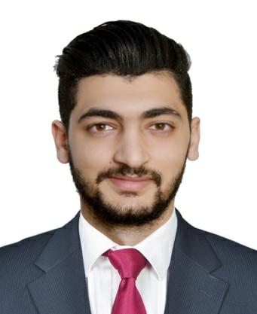
Mostafa

Accountant
26rdFebruary1994,Alexandria,Egypt

Address: Dubai

E-mail: Mostafa.384728@2freemail.com

Objective:

I'mpresentingthisresumetogainmoreexperiencesfromyourfield,upgrademycareer, facenewchalenges,andachievemyowngoalsthatthemostimportantoneistomake myfamily'slifebeter.

Education:

- BScinCommercial,AccountingDepartment.

- GraduatedfromAl-AzharUniversity,Cairo,Egypt(2012:2017)

- GraduatedinJuly2017.

- Grade:Good

ComputerSoftware:

- ICDL(Word,Excel,PowerPoint,Access,Outlook)

LanguageandCourses:

- Arabic(Native)

- English(Good)

  - CertificatedfromMinistryofDefenseLanguageInstitute,ModliAlexandria.

- QualifiedAccountingDiploma,Alexandria (2017)

  - Grade(VeryGood)

Personalexperience:

- CashieratJolibeRestaurantinAL-AIN,UAE.

o Achievedsalesgoalsthroughproductrecommendationstoguests.

1

  - Assistedwiththeflowofguestsbytakingfoodanddrinkordersasneeded.

  - Cashhandlingandendofdayrevenuereconciliationandapplicablepaperwork.

- CashieratAL-AINMalIceSkating,UEA

  - Responsibleforhandlingcashandcreditcardpayments.

- CalCenteratEccoOutsourcingCompanyinBorgAl-Arab,Alexandria,Egypt.

  - Receivinganddealingwithalinitialcustomercommunications

  - Providingaccurateinformationandadvice

  - Guidingalcustomerissuestoasatisfactoryconclusion

  - Folowinguponongoingcustomercasesandcommunicatingprogressto managementandcustomer.

- SalesIndooratAl-NileTravelAgentinAlexandria,Egypt.

  - IntroductiontoTravel,Tourism,andHelpingCustomerstoSelectBestFlights.

  - Forginglongtermandpositiverelationshipswithnewandexistingcustomers.

  - Responsibleforcolectingandrecordingdepositsandfinalpayments.

PersonalSkils:

- AbilitytocreateaspiritofCooperation.

- Workunderpressure.

- Abletohelpcustomersfindwhattheywant.

- Abletopromoteastoreanditsproductsthrougheffectivemarketing

2

- Readyandabletoworkindividualyorwithinateamenvironment

PersonalInformation:

- DateofBirth:26rdFebruary1994

- Nationality:Egyptian.

- MaritalStatus:Single.

- MilitaryService:Exempted.

ActivitiesandInterests:

- MemberofFederationofFacultyofCommerce,Al-AzharUniversity,Cairo,Egypt (2013:2016)

- VolunteerandMemberatSonaaEl-HayahAssociation,Cairo,Egypt(2012:2016)

- FormerandOrganizeratMarathonEl-Agamy,El-Agamy,Alexandria,Egypt(2015).

- TheaterActoratEzzDekhilahSteelCompanyClub,El-Agamy,Alexandria,Egypt(2015).

- VolunteeratRESALACharityAssociation,Cairo,Egypt(2012:2014).

3

