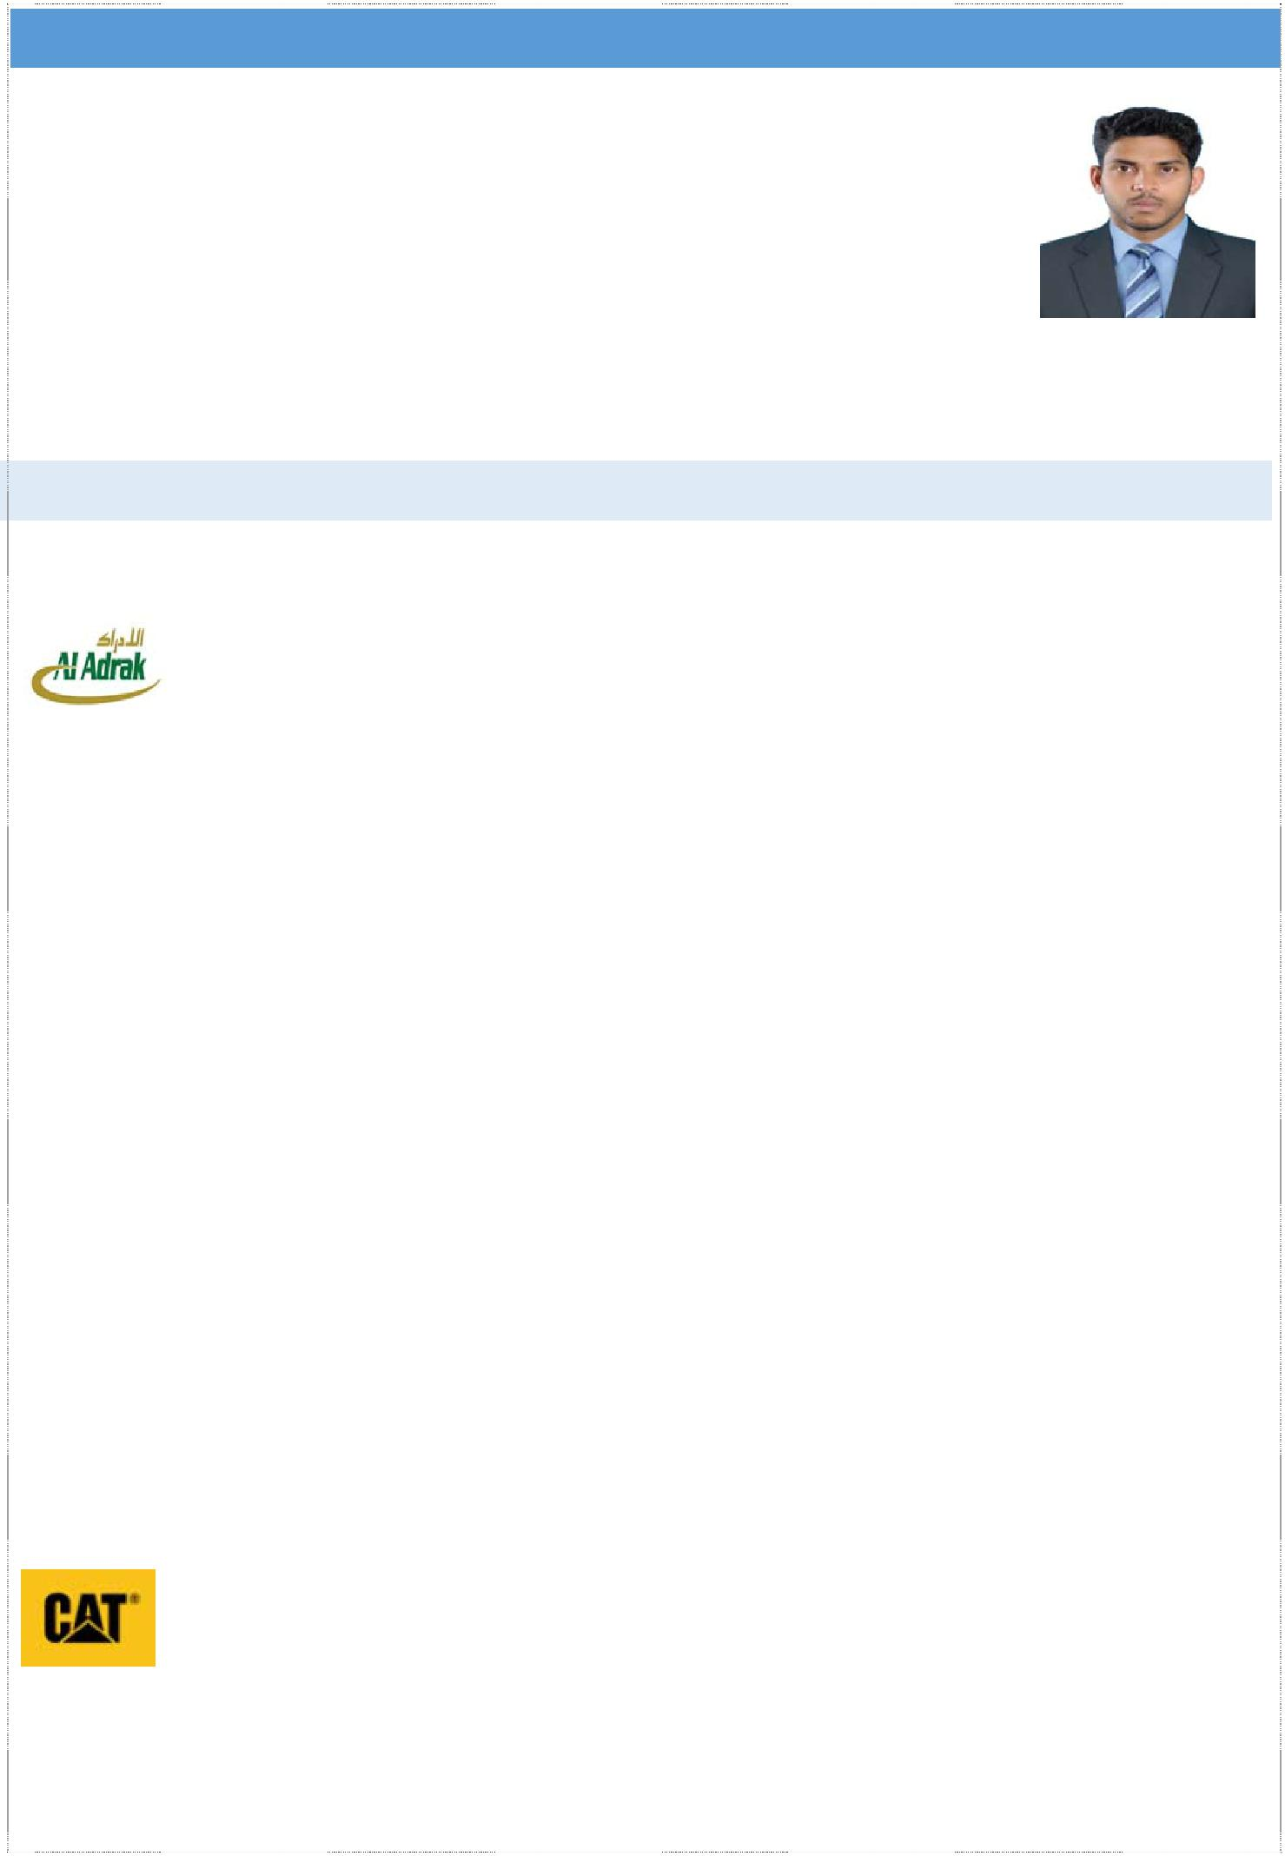
RESUME

JERIN

Dubai, UAE

E‐Mail: jerin.384745@2freemail.com

Objective: Seeking a position playing an important role in an organization that stretch my skills and capabilities, challenges me to perform exceptionally, preferably in a progressive and a competitive work culture in a technology driven company.

5 YEARS OF PROFESSIONAL EXPERIENCE

Professional Experience -1

Al Adrak Trading and | PMV/Machinery SUPERVISOR
Contracting Company LLC | Aug 2016 | - | Sept 2018
Muscat, Oman
Proven Job Role:

- Working as machinery floor in‐charge and preventive maintenance coordinator.

- Manage maintenance of breakdowns.

- Lead periodic service schedule.

- Machinery allocation as per site requirement.

- Preparing vehicles for passing Motor vehicle license (ROP Passing).

- Co‐ordinate Mechanical Technicians, Auto Electricians, Hydraulic Technicians and Operators.

- Arranging spare parts & give instructions to workers.

- Preventive & Predictive maintenance of Machineries & Power tools.

- Job card opening & closing through AXPERT (Company software) and documentation.

- Ensure Safety and Housekeeping of Workshop floor.

Major Projects:

• Construction of Border post ‐ Katmat Maliha, Oman

• Construction of Regional Headquarters ‐ Haima, Oman

• Construction of special task force ‐ Duqm, Oman

• Construction of special task force ‐ Khasab, Oman

• Construction of police complex ‐ Nimr, Oman

• Construction of woman police cadet’s academy ‐ Nizwa, Oman • Construction of Mazoon dairy project – Oman

Professional Experience -2
Caterpillar India Pvt Ltd |  | Operating Engineer Trainee
Melnallathur, Thiruvallur |  | March 2015 – July 2016
Tamil Nadu, India
Key Responsibilities:
• Worked on the assembly line of Caterpillar backhoe loader (424 B)
 |  | Page 1 of 3

- Ensure the quality aspects and time management

- Perform pre delivery inspections and snag rectification

- Exposure to checking torque of nuts, bolts, tubes and hoses

- Knowledge in tapping of threads and studs

- Knowledge of using DC tools and Pulse tools

Professional Experience -3

 | Pinnacle Motor Works Pvt Ltd |  | Mechanical Technician
 | NISSAN, Thrissur |  | August 2014 ‐ February 2015
 | Kerala, India
Responsibilities:
● Supervision & Control of trainee technician team
● | Coordination of maintenance team
● | Repair and Maintenance of Nissan Vehicles
● | Daily data analysis
Professional Experience -4
 | Geeyem Motors Pvt. Ltd. |  | Mechanical Trainee Technician
 | CHEVROLET, Thrissur |  | August 2010 ‐ July 2011
 | Kerala, India

Responsibilities:

- Participate/lead in meetings with supervisors and maintenance team

- Conduct regular check up

- Repair and Maintenance of Chevrolet Vehicles

- Doing Pre‐Delivery inspection

BRANDS / MODELS/ EQUIPMENTS WORKED

- Hydraulic excavators (JCB, CATERPILLAR, KOMATSU, VOLVO, KAWASAKKI, KOBELCO)

- Wheel loaders (JCB, CATERPILLAR, KOMATSU, VOLVO, KAWASAKKI)

- Telescopic material handlers (JCB, BOBCAT)

- Backhoe loaders (JCB, CATERPILLAR 424 B)

- Skid steer loaders (JCB, BOBCAT)

- Bulldozer (KOMATSU)

- Small Machinery and Power Tools

- Motor graders (CATERPILLAR, KOMATSU)

- Surface compacting equipment’s (BOMAG, JCB, CATERPILLAR, HAMM, MIKKASA, JCB VIBROMAX)

- Diesel generators (JCB, PERKINS, CUMMINS, CATERPILLAR, VOLVOPENTA, HIMONISA)

- Hydraulic breakers (RAMMER, MONTABERT, TEISAKU)

- Nissan & Chevrolet cars

CERTIFICATIOS

NON DESTRUCTIVE TESTING

ASNT NDT L‐I & L‐II Certified

Page 2 of 3

• | Ultrasonic Testing | • | Magnetic Testing
• | Radiographic Testing | • Visual & Optical Testing
• | Penetrant Testing | • | RTFI (Radiographic Filim Interpretation)

EDUCATIONAL QUALIFICATIONS

 | Diploma in Mechanical Engineering ( CGPA: 7.07) |  | Year 2011‐2014
 | Maharaja’s Technological Institute, Thrissur, Kerala , India
 | (Dept. of Technical Education, Govt. of Kerala)
 | ITI Mechanic ‐ Automobile | (77%) | Year 2008‐2010
 | St: Xavier’s Private Industrial Training Institute Pullur, Kerala
 | (National Council For Vocational Training, Govt. of INDIA)
 | Higher Secondary Examination (+2): Science ‐ 62% |  | Year 2006‐2008
 | Kerala State Educational Board ( S.S.L.C) : 77% |  | Year 2006
 | LINGUISTIC ABILITY
 | Malayalam, English, Hindi, Tamil
 | PERSONAL INFORMATION
 | Date of Birth | : 16‐10‐1990
 | Sex | : Male
 | Marital Status | : Single
 | Nationality | : INDIA

DECLARATION

I hereby declare that the above information given by me is correct and true to the best of my knowledge. If I were placed in your esteemed concern I will discharge my duties with at the most sincerity and to your full satisfaction

