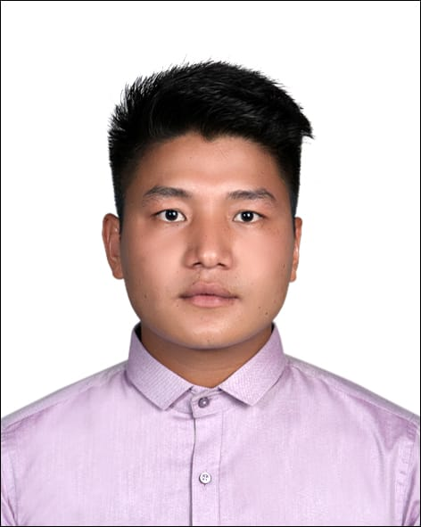

CURRICULUMN VITAE

Manoj

Manoj.384871@2freemail.com

I am enterprising young professional intending to obtain a platform which will allow me to utilize my Technical Skills, experience and willingness to meet organization objectives successfully. I have dynamic personality to stimulate and engage with people.

Experience
Accountant / Sales
Maden Traders and suppliers
3/2016 – 7/2017
- Stocks keeping and maintaining financial transactions..
- Interaction with customer directly regarding product deal.
- Maintaining Office and store room's display attractive.
- Supervise three co-workers in manufacturing depart according to the customer's demand in market.
Sales / Promoter
Sunshine Mobile and Accessories
9/2017- 6/2018
- Maintain Daybook and all financial transaction
- Product dealing and advertising the product through social network.
- Helping customer for choosing the right product as per the need

Extra-Curricular
Youth Red Cross Circle/Team Leader
Oct 2014 – Sep 2015
- Manage committee of 13 Students
- Conducted blood donation campaign successfully

Skills

Training Completed :
- Organizational Development
- Electronics
- Facilitator and Anchoring
- First Aid
- Basic Driving

Computer:-
- Basic Computer knowledge

Highlights:

- Adaptability accepts and supports the need for change whenever there is ambiguity.

- Identifies opportunities to use company resources

- Very good logical and analytical skills

- Excellent in interpersonal and decision-making ability .

- Reliable and hardworking

- Excellent interpersonal skills with customers

- Dedicated to improving skills, able to quickly learn new systems and technologies

Academic Credentials

Secondary Level from Little Flowers Secondary English Boarding School

- Higher Secondary LevelFrom Shree Janasahayog Higher Secondary School / Management

Personal Details

Date of birth : 02.10.1996
Married Status : Single
Nationality : Nepal
Languages Known : English (Fluent speaking & writing)
Hindi
Nepali ( Mother tongue )
Strength : Proactive , Innovative , Commanding Voice ,
Team player , Honest , Dynamic
Weakness : Emotional , Cannot say no!
Interests : Swimming , Listening Music and Travelling.

Declaration
Looking forward positively to have a good chance to work in yours company with suitable job matching profile to show my best efficiency

