Personal Data :
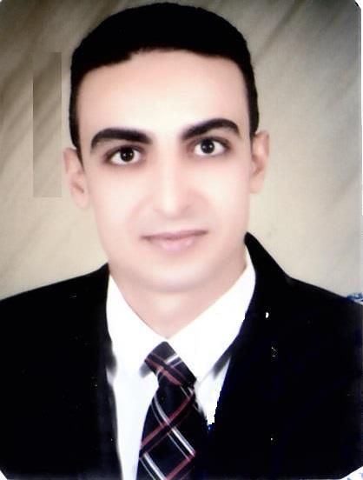

Full Name | : Shady
Date of Birth | : 14 / 8 / 1989
Nationality | : | Egyptian.
Visa Status | : | Visit Visa
Marital Status | : |  | single
Military service | : |  | final exempted
Email | : |  | Shady.384899@2freemail.com

Education:

University : Bachelor Degree in Civil Engineering -Civil

Department –Obour High Institute For Engineering And Technology academy 2013.
Current job :

Senior Engineer at Free Construction company for contractors.

Experience :

- 1-Alex DICOM Company From 1/ 10/ 2013 to 30 / 11/ 2014

- 2-Taba Comp. For Buildings From 1 / 1 / 2015 To 30 / 9/

2015 3-Alsafa comp. for contracting and buildings

- from1/10/2015 to 30/7/2016

- 4-worked in Doha for last year .

- 5-I have experience in government buildings hosspitals schools and post office .

- computer skills :

- Sap 2000

- AutoCAD

- Very good user of Microsoft Office all versions

- Very good user Excel

- Civil , Architectural Site Engineering Course

Curriculum includes

( Site mobilization , Concrete Works , Finishing Works , Site Management)

- Cambridge Global Collage For Phonetics & conversation with grade Excellent

- Cambridge Global Collage For Diploma preparation of Civil Engineer ( cad – sab

– civil – Qs) with grade Excellent

Languages :

Arabic : Fluent.

English : Fluent.

French : Fair .

Personal Skills :

- Dynamic and creative.

-Ability to work under high pressure.

-Ready to work abroad.

-Have a driving private license.

