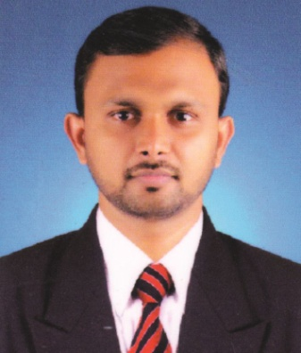
CURRICULAM VITAE

SARAFUDHEEN
Place : Dubai.
Visa Status : Visit visa
Email : sarafudheen.384900@2freemail.com

CAREER OBJECTIVE

To work as a challenging professional in the field of management in a growth oriented organization that can take full advantage of my interpersonal skills.

CORE SKILLS:

Windows Application Packages

PROFESSIONAL EXPERIENCE:

Department: Administration & Human Resource.

JOB DESCRIPTION

- Act as liaisons among governing boards, medical staff and department heads.
- Recruit, hire and evaluate assistant administrators, nurses and doctors
- Plan budgets and set rates for health services
- Planning the marketing & branding activities.
- Handle hospital routine operations.
- Execute clinical administrative policies and initiate action to enhance patient care programs.
- Examine and resolve complaints received from staff, visitors, patients and physicians.
- Staff recruitment, selection and training.
- Responsible for creating database of potential customers and updating the same.
- To develop brochures, leaflets, banners, website and other visual media presentations whatever required for the marketing activities.
- Responsible for tie up with new insurance companies, renewal of existing contracts etc.

MES MEDICAL College Hospital, Kerala, India. (17/06/2013 to 06/12/2014)
Department: Public Relations & General Administration.
JOB DESCRIPTION
- Planning publicity strategies and campaigns
- Dealing with enquiries from the public, the press, and related organizations.
- Organizing promotional events such as press conferences, open days, exhibitions, tours and visits.
- Speaking publicly at interviews, press conferences and presentations.
- Analyzing media coverage

ASTER MIMS HOSPITAL, Kottakkal, Kerala, India. (01/02/2012 to 13/06/2013)
Department : Business Development and General Administration.

JOB DESCRIPTION
- Overseeing and developing marketing campaigns and Promotional activities.
- Maintaining websites and looking at data analysis.
- Organising events and product exhibitions.
- Coordinating internal marketing and Managing campaigns on social media.

EDUCATION & TRAINING:

MBA | Sri Venkateswara college of computer applications and Management, Coimbatore. | Anna University of Technology, Coimbatore. | 74%
Bsc.  Biochemistry | Markaz arts and science college, Karthala, Kerala. | Calicut University | 68%

MBA SPECIALIZATION

- Human Resource
- Marketing

OTHER DETAILS:

Date of Birth : 30\05\1988
Marital Status : Married
Languages known : English, Hindi, Malayalam, Tamil.

DECLARATION:

I hereby declare that the above-mentioned details are true to the best of my belief and knowledge.
Sarafudheen

