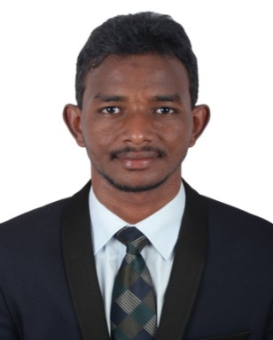
Ali Abdellatif

E-mail: aliabdellatif.384933@2freemail.com

Personal Details:

- Date of birth: 01-01-1991
- Gender: Male
- Marital status: Single
- Nationality: Sudanese
- Language: Arabic – English
- Address: UAE – Dubai
- Visa status: Visa

Career Objective:

Seeking a challenging position in a progressive organization that satisfies my potentials & offers opportunities for an advanced promising career by effectively utilizing and improving my practical skills within a dynamic work group.

Education Qualifications:

2014
Degree : Bachelor Degree in Computer Applications (BCA)
University: Osmania University, Hyderabad, India
College : Nizam College

Working Experience:

2015 Jan – June 2016

Customer Service Representative, Arabian Company For Computers (Sudan):

Key Role Responsibilities:

- Enter new customer information.
- Answered client inquiries in person, emails and via telephone.
- Provide customer with product and service information.
- Follow up customers when necessary.
- Manage and resolve customer complaints.
- Inform customers with about new products.
- Update exsiting customer information.
- complete logs & produce call reports.
- Process orders, forms and applications.

2017 Feb - May 2018

IT support Technician.

Job Duties:

- Set up and configure computer hardware, software, system, printers and scanners.
- Provide accurate information on IT products or services.
- Determine the best solution based on the issue and details provides.
- Create and cabling LAN/ WAN networks connections.
- Direct under solved issues to the next level of support personnel.
- Perform troubleshooting through diagnostic techniques, repairs and data restoration.

Technical Skills

- Microsoft Office (Access, Excel, PowerPoint).
- Good data analysis, problem solving skills and customer focus.
- Self-motivated and quick-learner.
- Strong skills network router and TCP/IP configuration, Internet/Smart devices.
- Strong communications skills in English and Arabic.
- Strategically and under tight deadlines, with strong attention to detail.

Declaration:

I hereby declare that all the above furnished facts are true to the best of my knowledge and belief.

