RESUME

BRINDHA.
Email : brindha.384989@2freemail.com
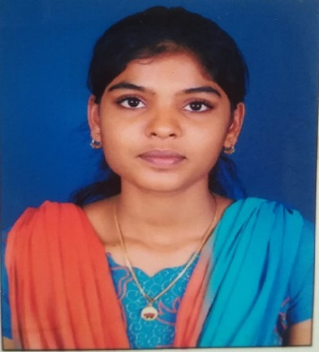
OBJECTIVE
To secure a challenging position in a reputable organization to expand my learnings, knowledge and skills.

EDUCATIONAL QUALIFICATION

Degree | Branch | Year of Passing | College/School | University/Board | Percentage
BE | CIVIL | 2018 | SCAD college of engineering and technology | Anna university | 80
HSC | COMPUTER  SCIENCE | 2014 | Govt. Hr. Sec School  Kalakad | State Board of Education | 78.67
SSLC | _ | 2012 | K.A.M.P Meerania Hr. Sec School  Kalakd | State Board of Education | 84.4
PROFESSIONAL EXPERIENCE
Mini project : Hotel designing and planning by using AUTO CAD software.
Main project :Pratial replacement of coarse aggregate by using cockle shell.
5 months experience for design engineer in Sathyam construction.
SKILL
- Designing software : AUTOCAD , REVIT ARCHITECTURE.
- Microsoft Excel , Microsoft Word .
- Languages known : Tamil , English .
REFERENCE
- Mrs.B.SathyaAsst.Prof in SCAD college of engineering and technology.
Phone no :+91 8508695036
- Mr.P.VigneshAsst.Prof in SCAD college of engineering and technology.
Phone no : +91 9790286848

PERSONAL INFORMATION
Full Name | Brindha.
Date of Birth | 24-11-1996
Gender | Female
Age | 21
Languages Known | Tamil & English (Read & Write)
Mother Tongue | Tamil
Marital Status | Unmarried

DECLARATION
Here by declare that all information provided by me is true to the best of my knowledge. I promise to serve you to the best of my abilities.

