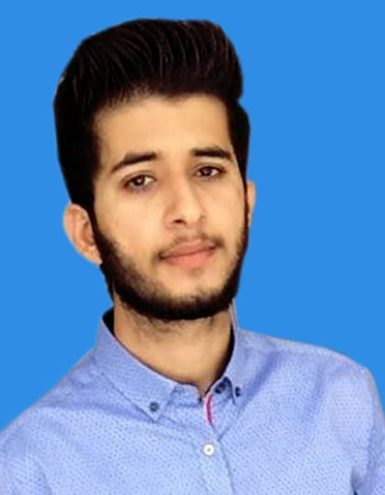
Zammad

Position: Electrical Engineer

Educational Qualifications: BS Electrical Engineering
Email: zammad.385003@2freemail.com
Current Location: Abu Dhabi, UAE
Visa Status: Visit Visa

Objective

To develop a professional career in Electrical Engineering field, where I can apply my knowledge, talents
And ideas that company offers me the opportunity to work, showing my honesty, commitment and excellence; participating actively in activities that promote the continuous success.

Summary of Career
- Worked as “Internee” in “FDL Private Limited”, Pakistan.
- Training on Boilers.
- Learn about construction and working of boilers.
- Learn about different types of chillers.
- Learn about compressor types.
- Learn how to manage and solved the facing problems in field.
- Worked as “Trainee Engineer” in “Cotton Web Private Limited”, Pakistan.
- Training on Boilers both coal fire and gas or diesel fire.
- Learn working and construction of boilers.
- Training on screw type compressors.
- Learn working and construction and uses of compressors.
- Also learn about reciprocating compressors.
- Learn about various types of chillers.
- Studied and solved the problem faced in the field. Coordination with vendorsand other departments for instrument requirements and Inter discipline Communication.
- Proficient in the use of MS Excel, MS Word, MS PowerPoint.
- Excellent communication skills, both verbal and written.

Educational Qualifications
- BS Electrical Engineering from University Of Lahore, Pakistan --June 2018
- FSC (Pre-Engineering) --September 2014
- Matric --July 2012

Final Year Project

Grid Connected Photo Voltaic System.

Computer Skills/ Software Skills
- MS Word, Power Point
- Software :NI Multisim, Auto Cad
- Programming Languages : ‘C’ Language

Seminars / Trainings / CO-CURRICULAR ACTIVITIES
- Member of Electrical And Control Engineering Society – At ECE Council UOL, Pakistan
- Attend Seminar on Control Systems – At University Of Lahore,Pakistan
- Attend Training on Soldering – At University Of Lahore,Pakistan
- Attend Seminar on Load Sharing In Micro Grids - At ECE Council UOL, Pakistan
- Attend And Organize Educational Talk on Photovoltaic Systems.– At ECE Council UOL, Pakistan

Personal Details
- Date of Birth : 25 june,1997
- Gender : Male
- Religion : Islam
- Nationality : Pakistan
- Marital Status : Un Married
- Language Known : English, Urdu, Punjabi

